
AMERICAN INTERNATIONAL
UNIVERSITY BANGLADESH (AIUB)

FACULTY OF SCIENCE & TECHNOLOGY DEPARTMENT OF
ELECTRICAL AND ELECTRONICS ENGINEERING

Spring 2024-2025

DIGITAL LOGIC AND CIRCUITS LABORATORY

Section: D Group: 03

LAB REPORT NAME:
Design of a Digital to Analog and Analog to Digital Converters.

Supervised By:

S M TANVIR HASSAN SHOVON

Submitted By:

SL | Student ID | Student Name
1. | 23-50856-1 | Basudeb Kundu

Submition Date:24.06.2025

Title: Design of a Digital to Analog and Analog to Digital Converters.

Part I: Design of a Digital to Analog Converter

Theory and Methodology:

One common requirement in electronics is to convert signals back and forth between analog and digital forms. Most such conversions are ultimately based on a digital-to- analog converter circuit. Therefore, it is worth exploring just how we can convert a digital number that represents a voltage value into an actual analog voltage.

Digital-to-Analog Converters

In electronics, a digital-to-analog converter (DAC, D/A, D2A or D-to-A) is a function that converts digital data (usually binary) into an analog signal (current, voltage, or electric charge). An analog-to-digital converter (ADC) performs the reverse function. Unlike analog signals, Digital data can be transmitted, manipulated, and stored without degradation, albeit with more complex equipment. But a DAC is needed to convert the digital signal to analog, for example to drive an earphone or loudspeaker amplifier and produce sound (analog air pressure waves).

DACs and their inverse, ADCs, are part of an enabling technology that has contributed greatly to the 'digital revolution'. To illustrate this, consider a typical long-distance telephone call. The callers voice is converted into an analog electrical signal by a microphone. The analog signal is then converted to a digital stream by an ADC. That digital stream is then divided into packets where it will be mixed with other digital data, not necessarily audio. The digital packets are then sent to the destination, but each packet may take a completely different route and may not even arrive at the destination in the correct time order. The digital voice data is then extracted from the packets and assembled into a digital data stream. A DAC converts it into an analog electrical signal which drives an audio amplifier which in turn drives a loudspeaker which finally produces sound. Of course, this is a simplified and stylized description, but it does illustrate one vital role of ADCs and DACs.

There are several DAC architectures; the suitability of a DAC for a particular application is determined by six main parameters: physical size, power consumption, resolution, speed, accuracy, cost. Due to the complexity and the need for precisely matched components, all but the most specialist DACs are implemented as integrated circuits (ICs). Digital-to-analog conversion can degrade a signal, so a DAC should be specified that that has insignificant errors in terms of the application.

DACs are commonly used in music players to convert digital data streams into analogue audio signals. They are also used in televisions and mobile phones to convert digital video

© Dept. of EEE, Faculty of Engineering, American International University-Bangladesh (AIUB | 1

data into analog video signals which connect to the screen drivers to display monochrome or color images. These two applications use DACs at opposite ends of the speed/resolution trade-off. The audio DAC is a low speed high resolution type while the video DAC is a high speed low to medium resolution type. Discrete DACs would typically be extremely high speed low resolution power hungry types, as used in military radar systems. Very high speed test equipment, especially sampling oscilloscopes, may also use discrete DACS.
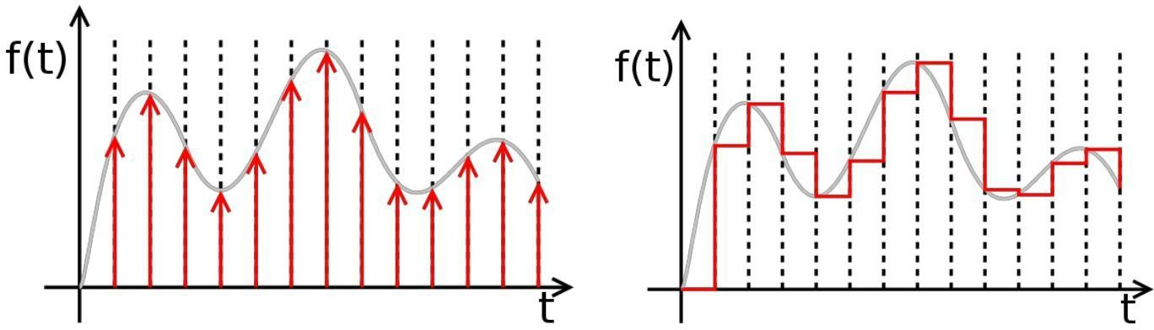

Ideally sampled signal |  | Piecewise constant output of an
 |  | idealized DAC lacking a
 |  | reconstruction filter. In a practical
 |  | DAC, a filter or the finite
 |  | bandwidth of the device smoothes
 |  | out the step response into a
 |  | continuous curve.

A digital-to-analog converter, or DAC for short, converts a digitally coded number to a voltage proportional to the number. For example, if a number N is supplied to a DAC, the output voltage will be proportional to N: Vout = N × B The constant of proportionality, B, is normally determined from the ratio of the reference voltage, Vref, and the maximum value that N can have, Nmax, B = Vref / Nmax so that Vout = Vref N / Nmax A common way to make a DAC is with an OpAmp circuit. Recall the circuit for the summing amplifier.

Binary Weighted Digital-to-Analog Converter:

The following circuit is a basic digital-to-analog (D to A) converter. It assumes a 4-bit binary number in Binary-Coded Decimal (BCD) format, using +5 volts as a logic 1 and 0 volts as a logic 0. It will convert the applied BCD number to a matching (inverted) output voltage. The digits 1, 2, 4, and 8 refer to the relative weights assigned to each input. Thus, 1 is the Least Significant Bit (LSB) of the input binary number, and 8 is the Most Significant Bit (MSB).
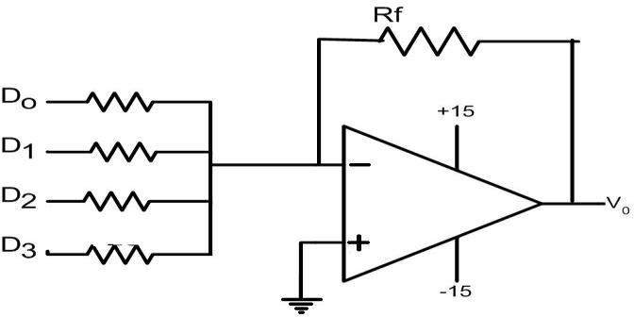

Fig1: Binary Weighted Digital to Analog converter.

© Dept. of EEE, Faculty of Engineering, American International University-Bangladesh (AIUB | 2

Experiment 10 Lab Manual

If the input voltages are accurately 0 and +5 volts, then the "1" input will cause an output voltage of -5 × (4k/20k) = -5 × (1/5) = -1 volt whenever it is a logic 1. Similarly, the "2," "4," and "8" inputs will control output voltages of -2, -4, and -8 volts, respectively. As a result, the output voltage will take on one of 10 specific voltages, in accordance with the input BCD code.

Unfortunately, there are several practical problems with this circuit. First, most digital logic gates do not accurately produce 0 and +5 volts at their outputs. Therefore, the resulting analog voltages will be close, but not really accurate. In addition, the different input resistors will load the digital circuit outputs differently, which will almost certainly result in different voltages being applied to the summer inputs.

R/2R Ladder Digital-to-Analog Converter:

This improved circuit overcomes the problem of using many resistors. Instead it uses only two valued resistor.

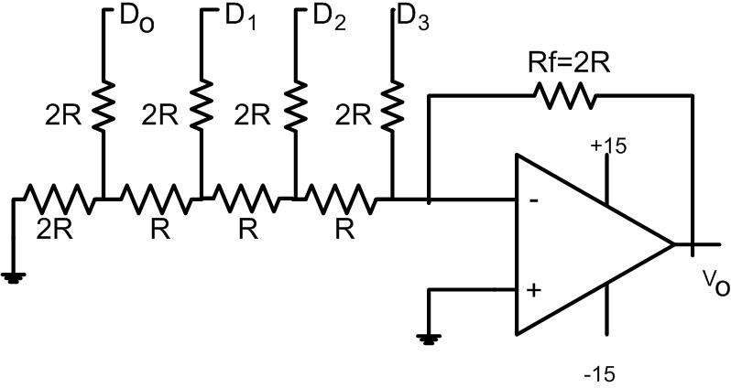
Fig 2: R/2R Ladder DAC

The circuit above performs D to A conversion a little differently. Typically the inputs are driven by CMOS gates, which have low but equal resistance for both logic 0 and logic 1. Also, if we use the same logic levels, CMOS gates really do provide +5 and 0 volts for their logic levels.

The input circuit is a remarkable design, known as an R-2R ladder network. It has several advantages over the basic summer circuit we saw first:

- Only two resistance values are used anywhere in the entire circuit. This means that only two values of precision resistance are needed, in a resistance ratio of 2:1. This requirement is easy to meet, and not especially expensive.

- The input resistance seen by each digital input is the same as for every other input. The actual impedance seen by each digital source gate is 3R. With a CMOS gate resistance of 200 ohms, we can use the very standard values of 10k and 20k for our resistors.

© Dept. of EEE, Faculty of Engineering, American International University-Bangladesh (AIUB | 3

- The circuit is indefinitely extensible for binary numbers. Thus, if we use binary inputs instead of BCD, we can simply double the length of the ladder network for an 8-bit number (0 to 255) or double it again for a 16-bit number (0 to 65535). We only need to add two resistors for each additional binary input.

- The circuit lends itself to a non-inverting circuit configuration. Therefore we need not be concerned about intermediate inverters along the way. However, an inverting version can easily be configured if that is appropriate.

Introduction:

This lab describes the design of a Digital to Analog Converter (DAC). Two types of design are shown in this lab, binary weighted DAC and R/2R ladder DAC design. Finally student will compare both the design to conclude which design is efficient and why.

Apparatus:

1) | IC741 OPAMP | 1[pcs]
2) | Resistors as required. | 14[pcs]
3) | Oscilloscope.

Precautions:
1.The DC source must never be turned on before the circuit has been placed correctly and checked thoroughly.
2.The circuit must be inspected carefully for any short circuits before it is powered.

Experimental Procedure:
• The Binary Weighted Digital to Analog Converter should first be set up on the trainer board as shown in Fig1.
• The sequence 1010 should be applied to D0, D1, D2, and D3 respectively. The output should be observed on the oscilloscope.
• The R/2R ladder should then be set up on the trainer board.
• Step 2 should be repeated for the R/2R DAC.

Lab Measurement:

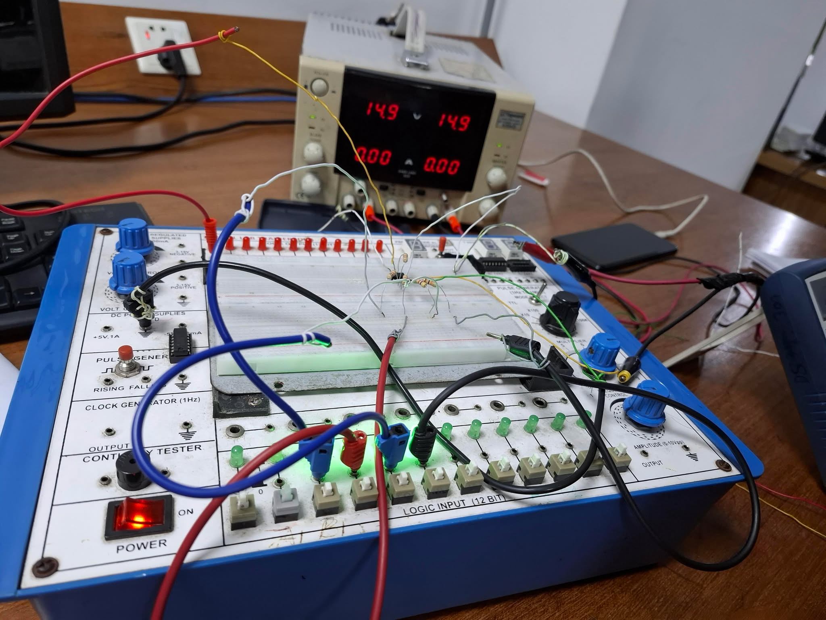

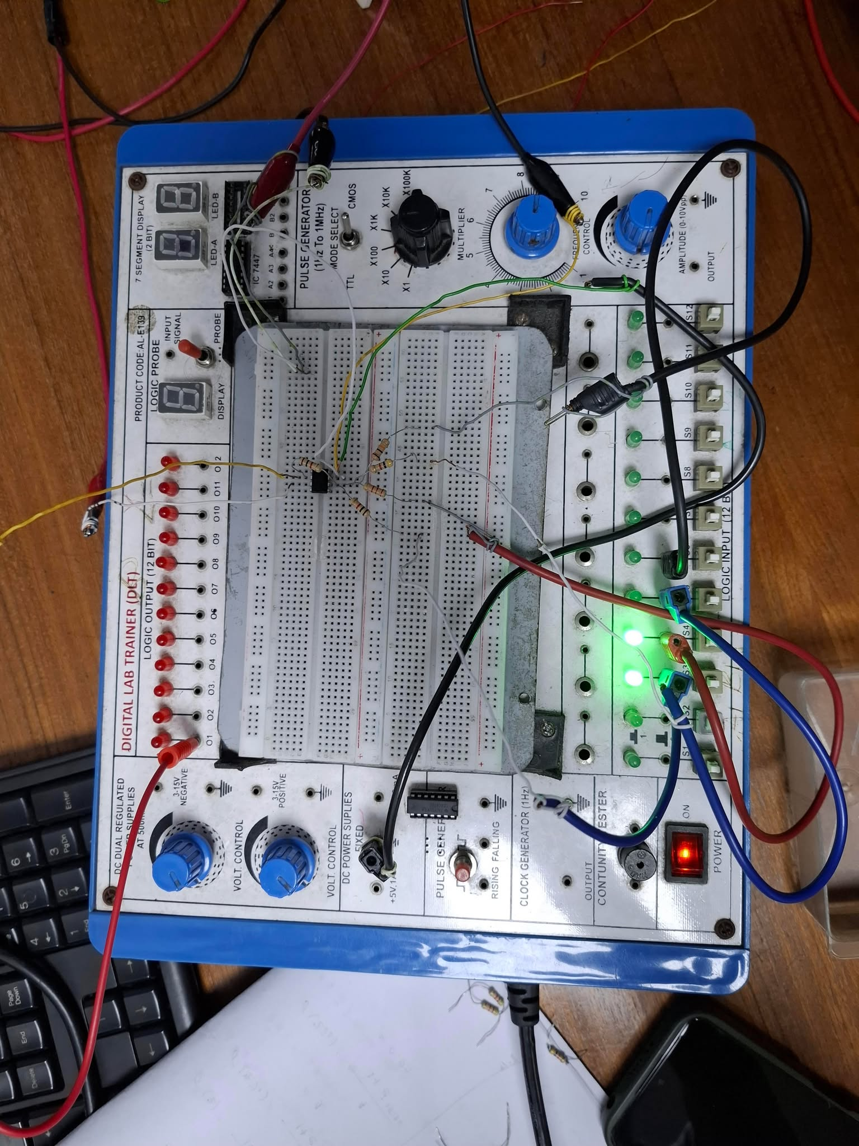

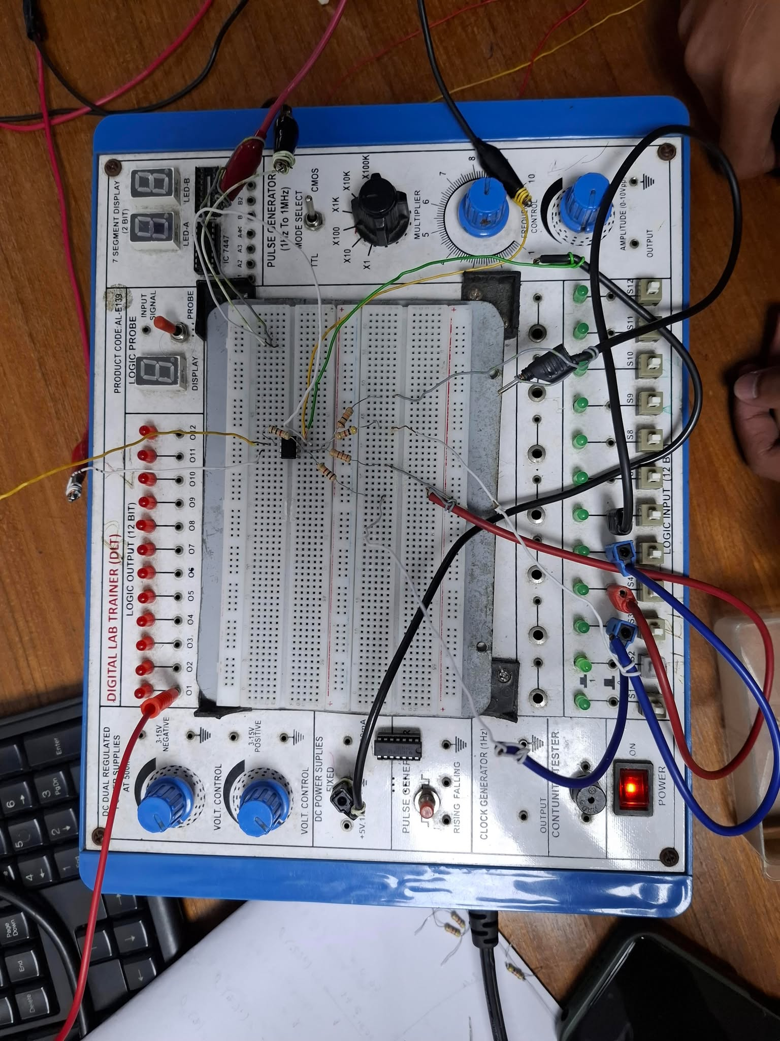
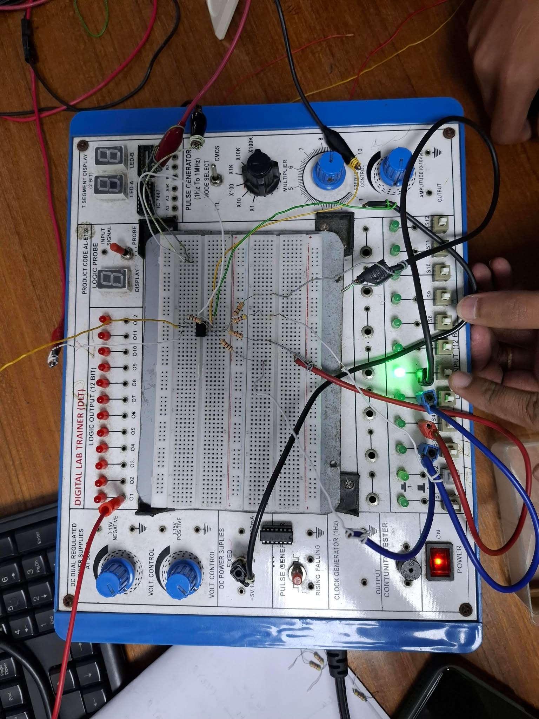

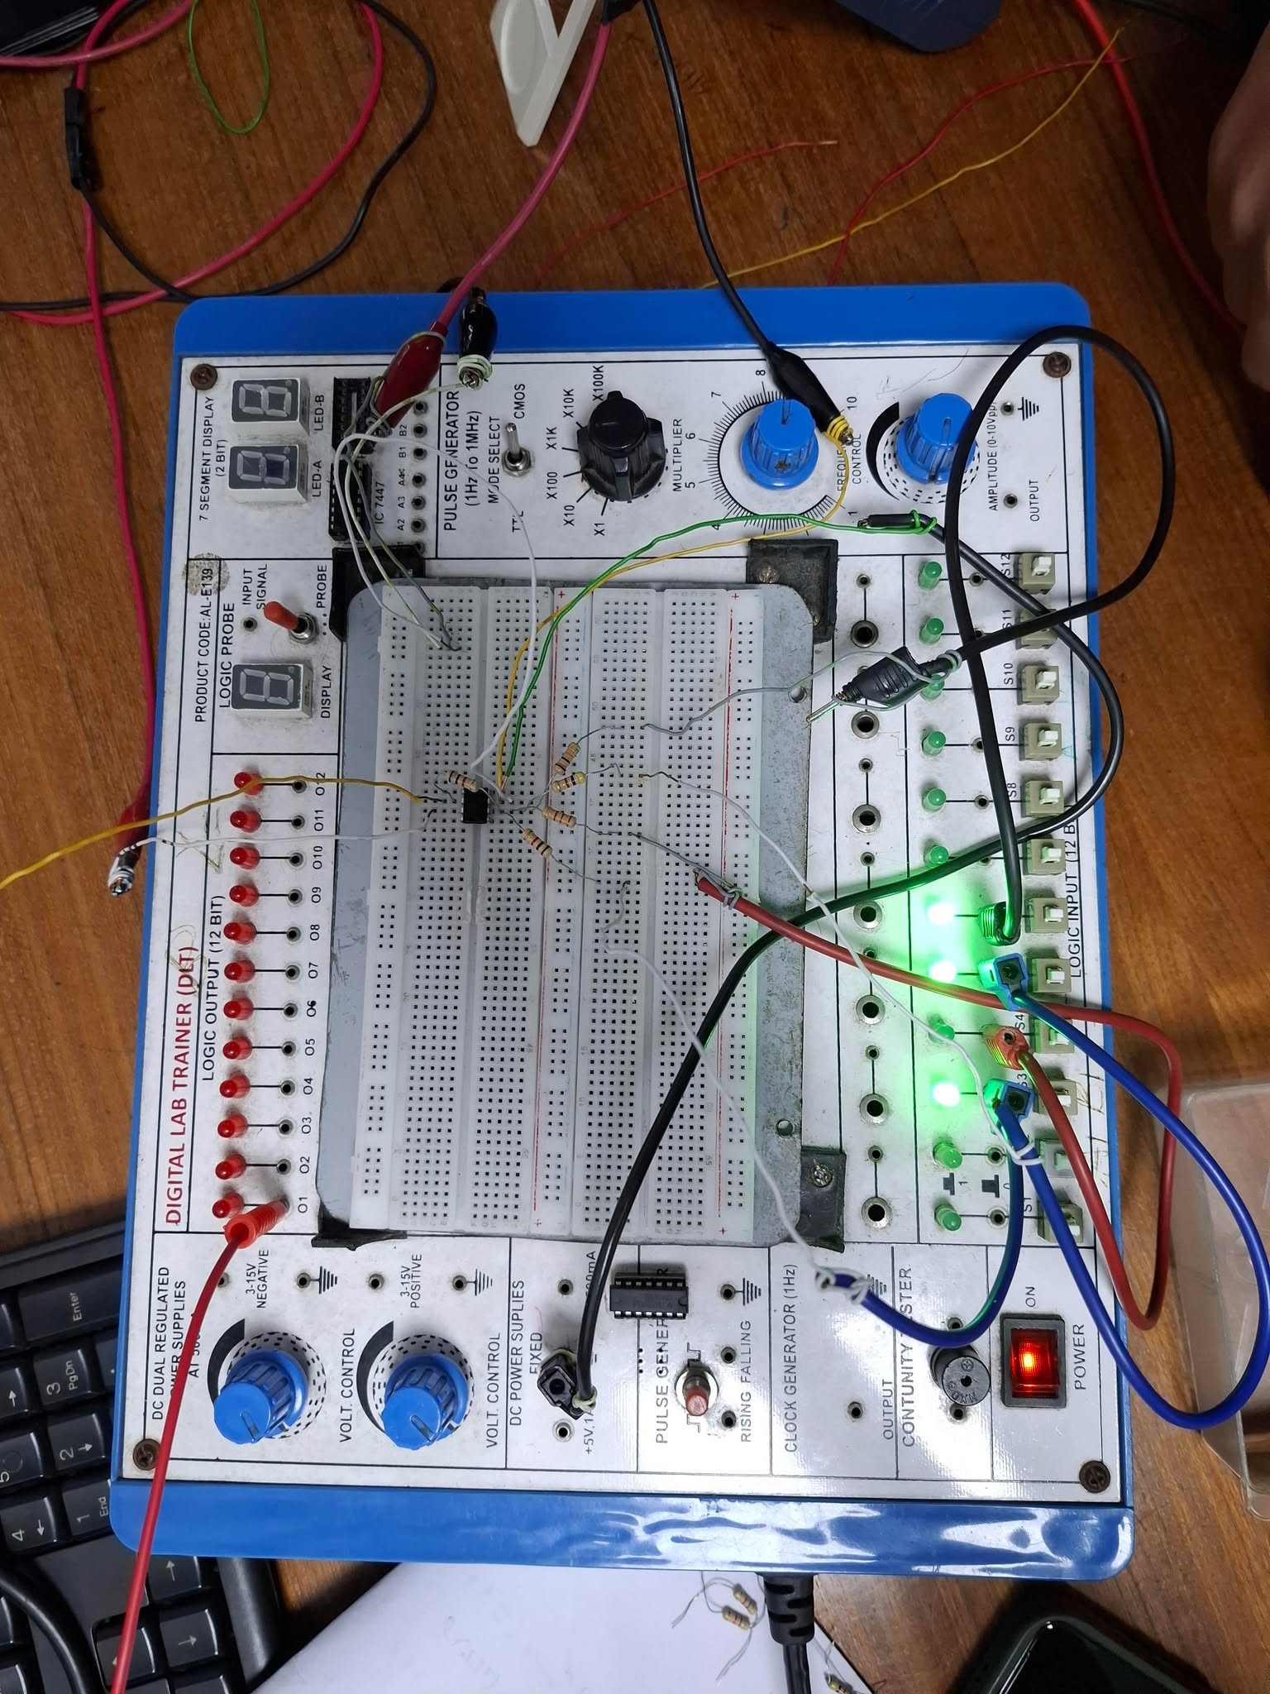

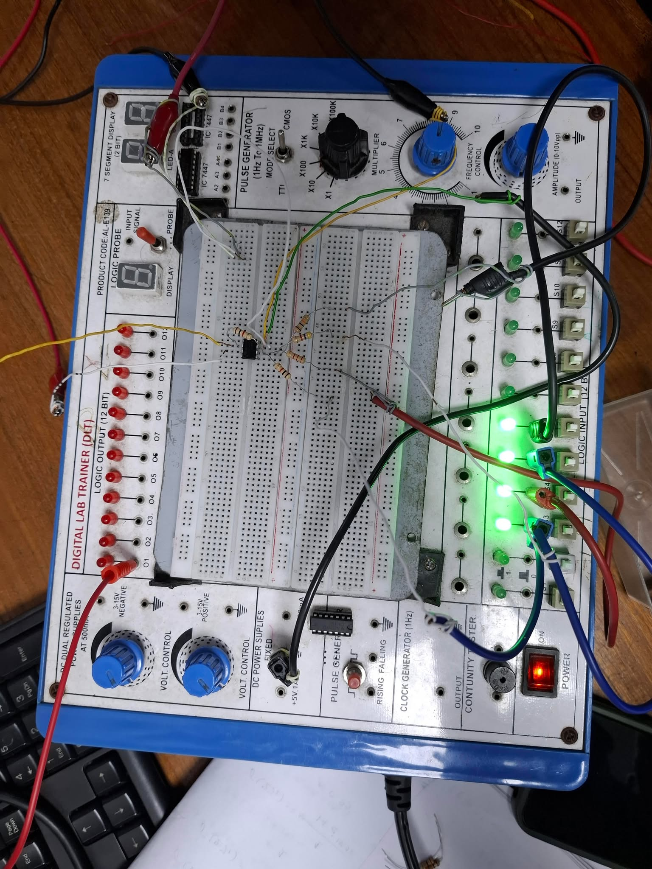

Simulation :

Binary Weighted Digital to Analog converter

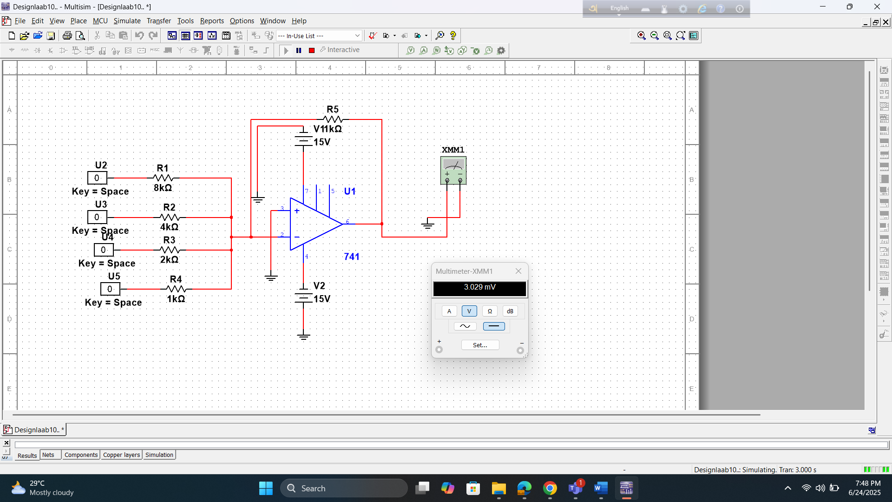

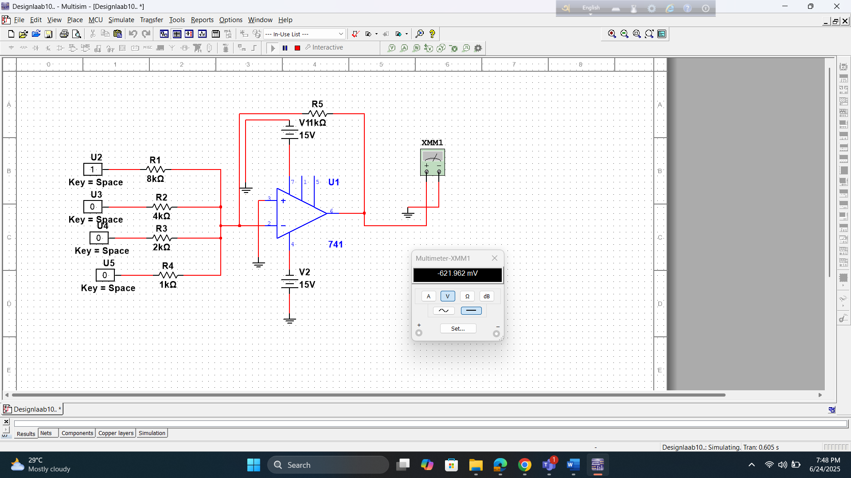

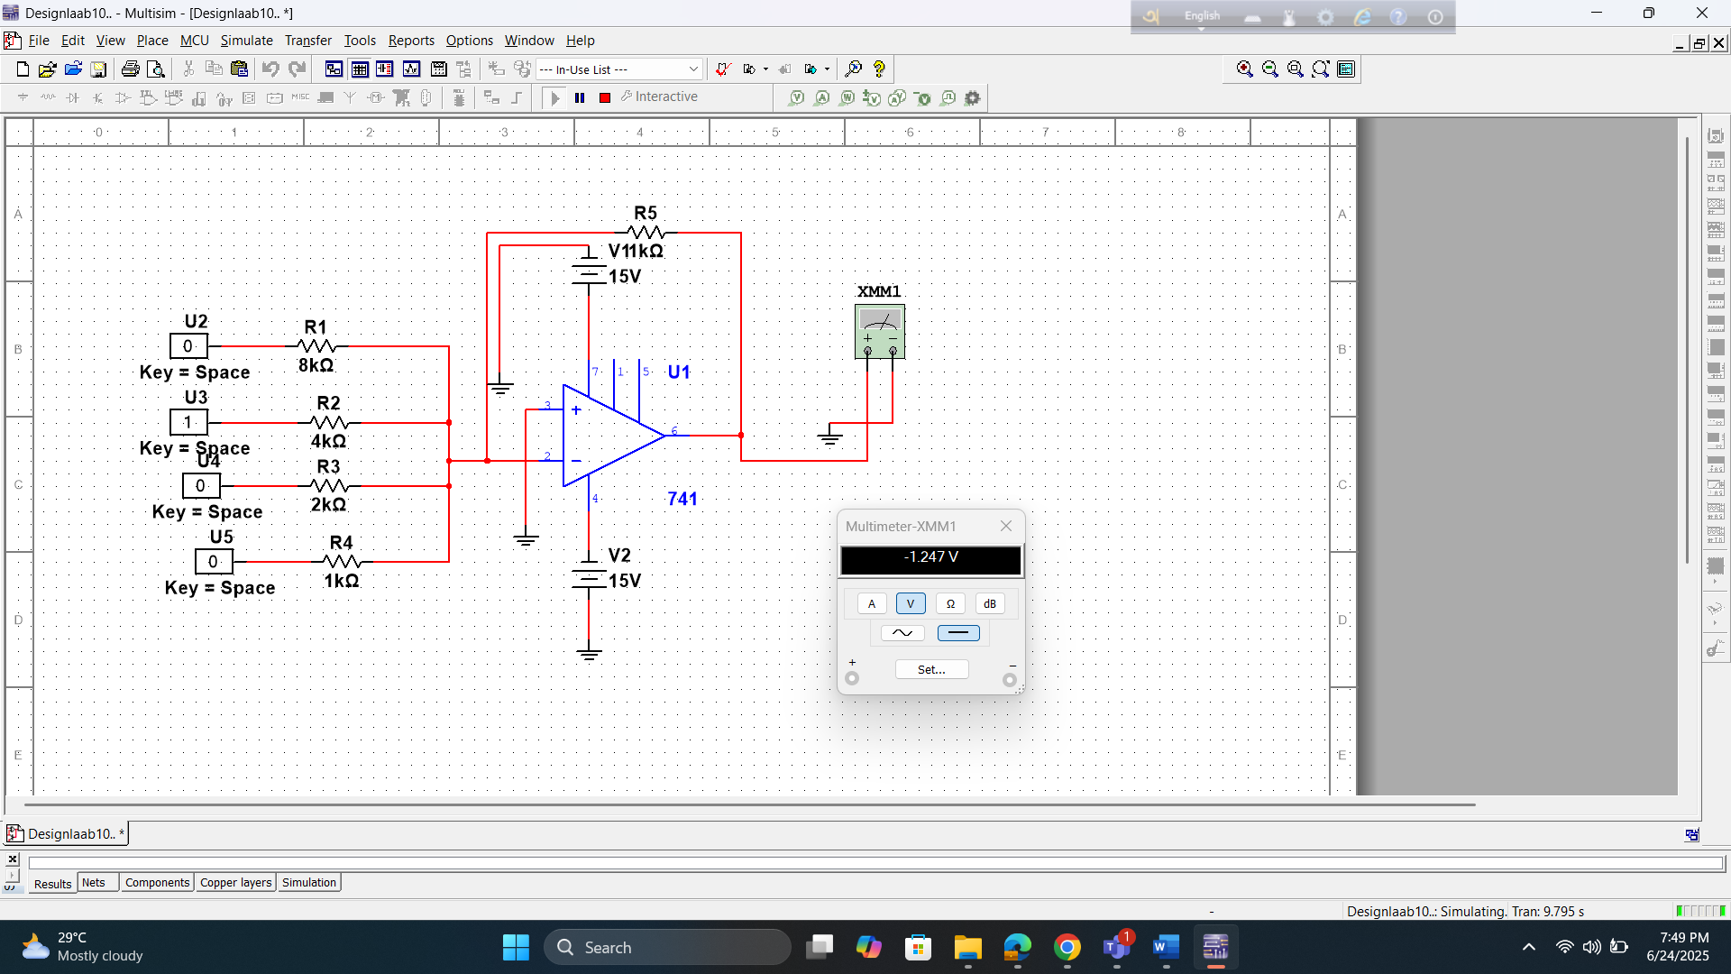

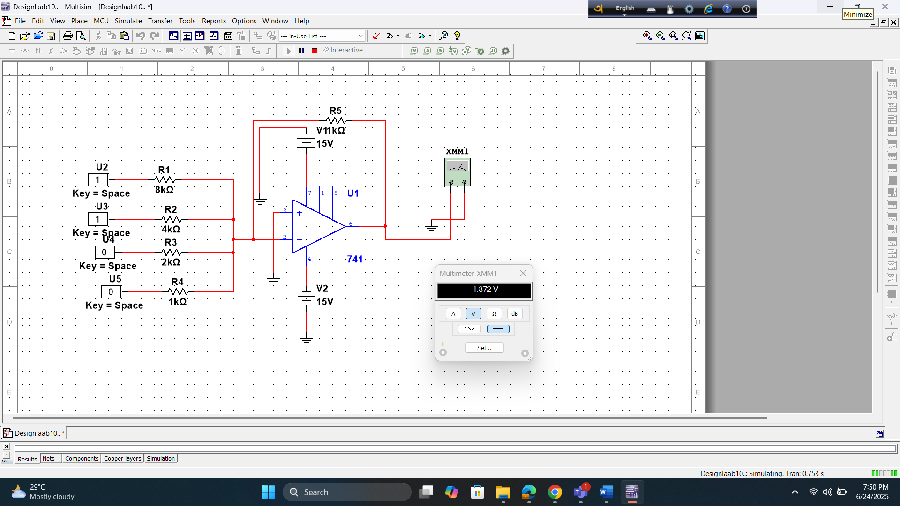

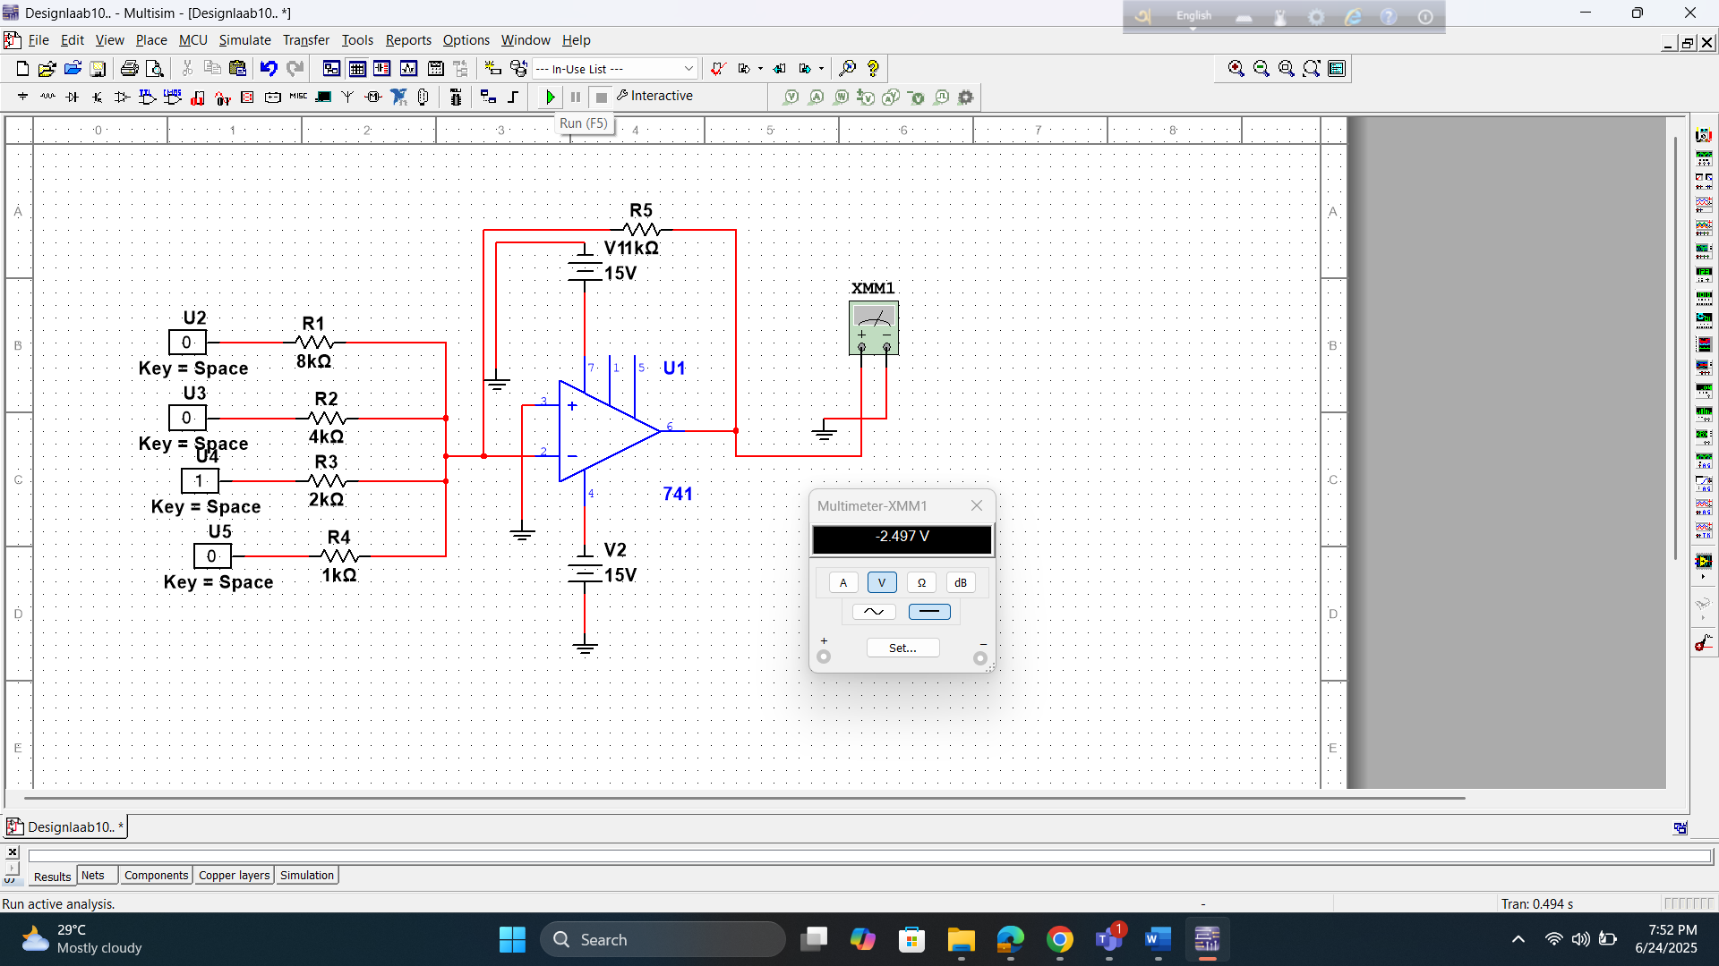

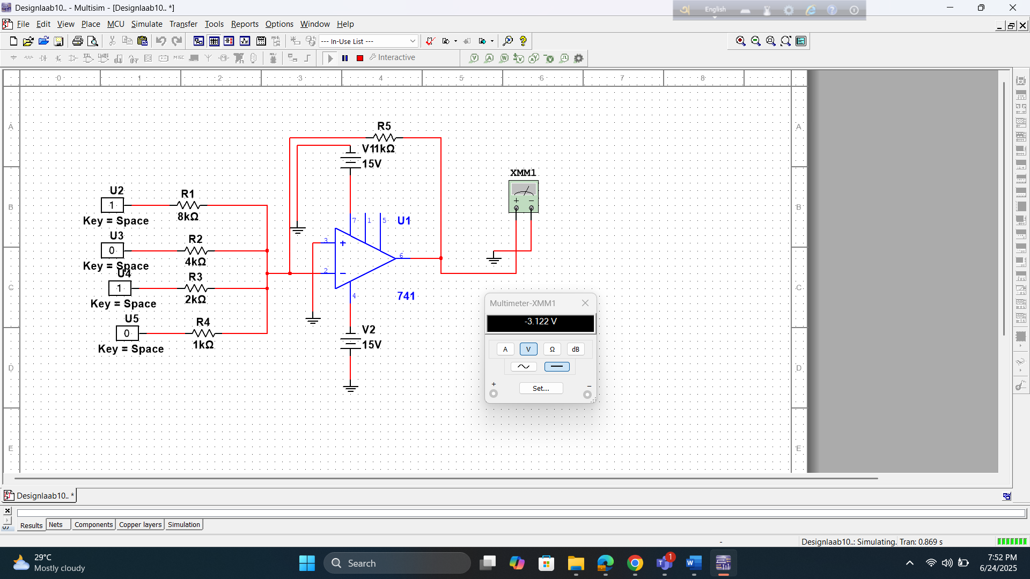

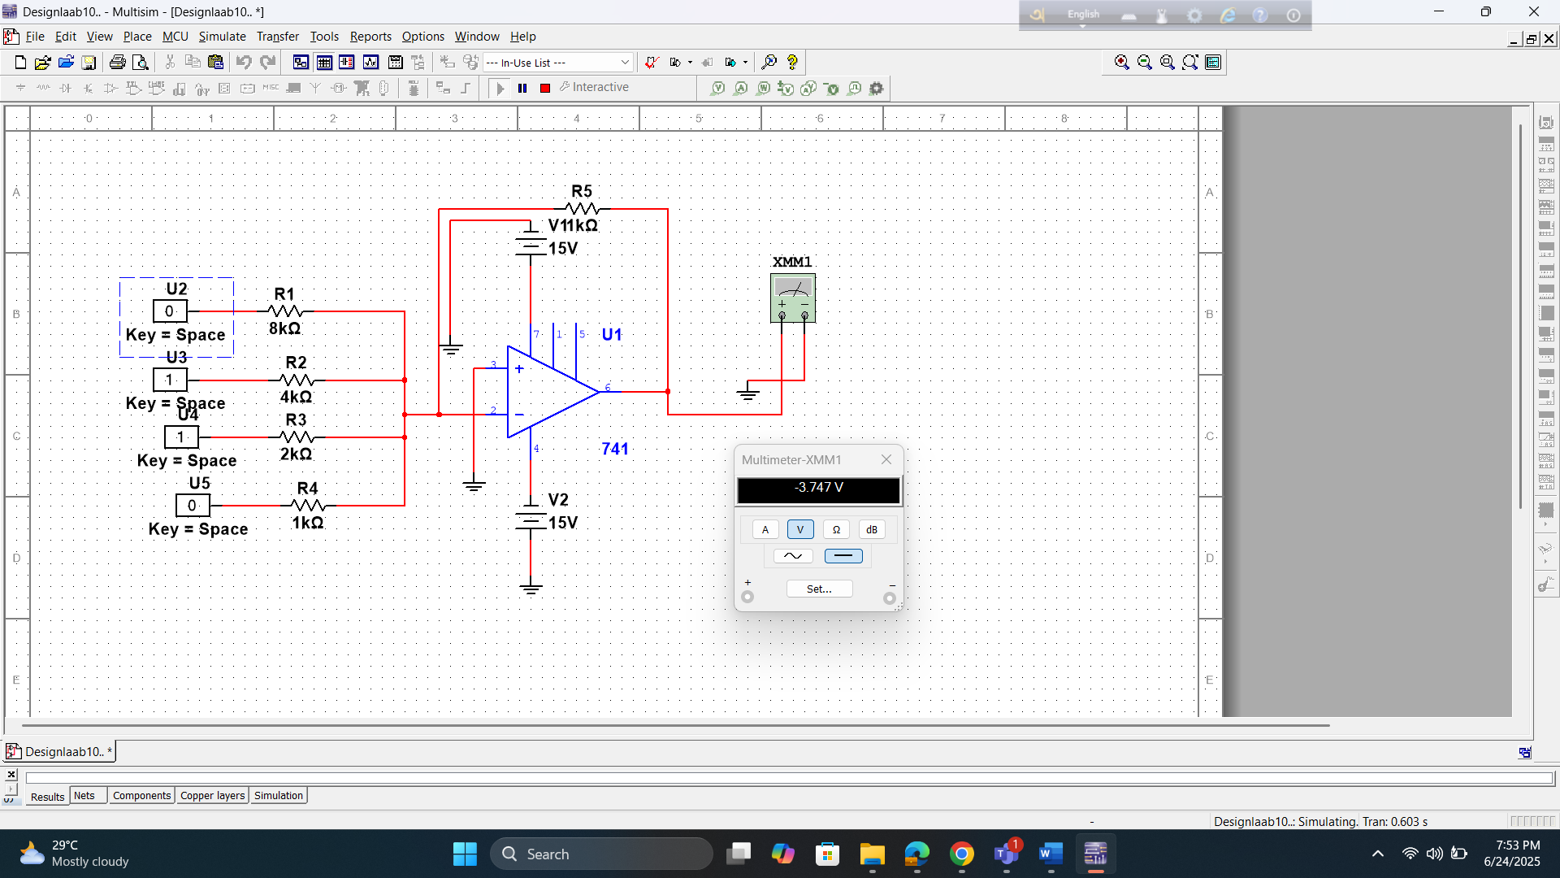

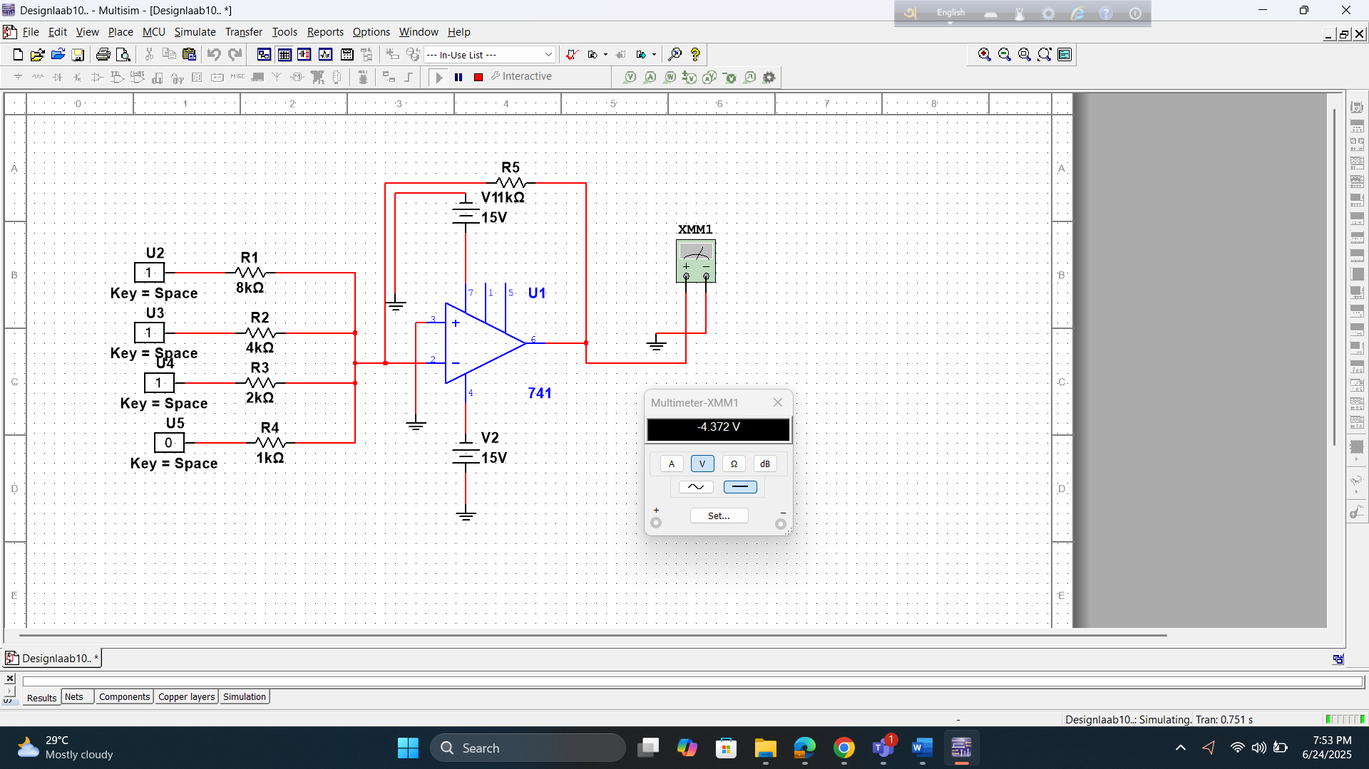

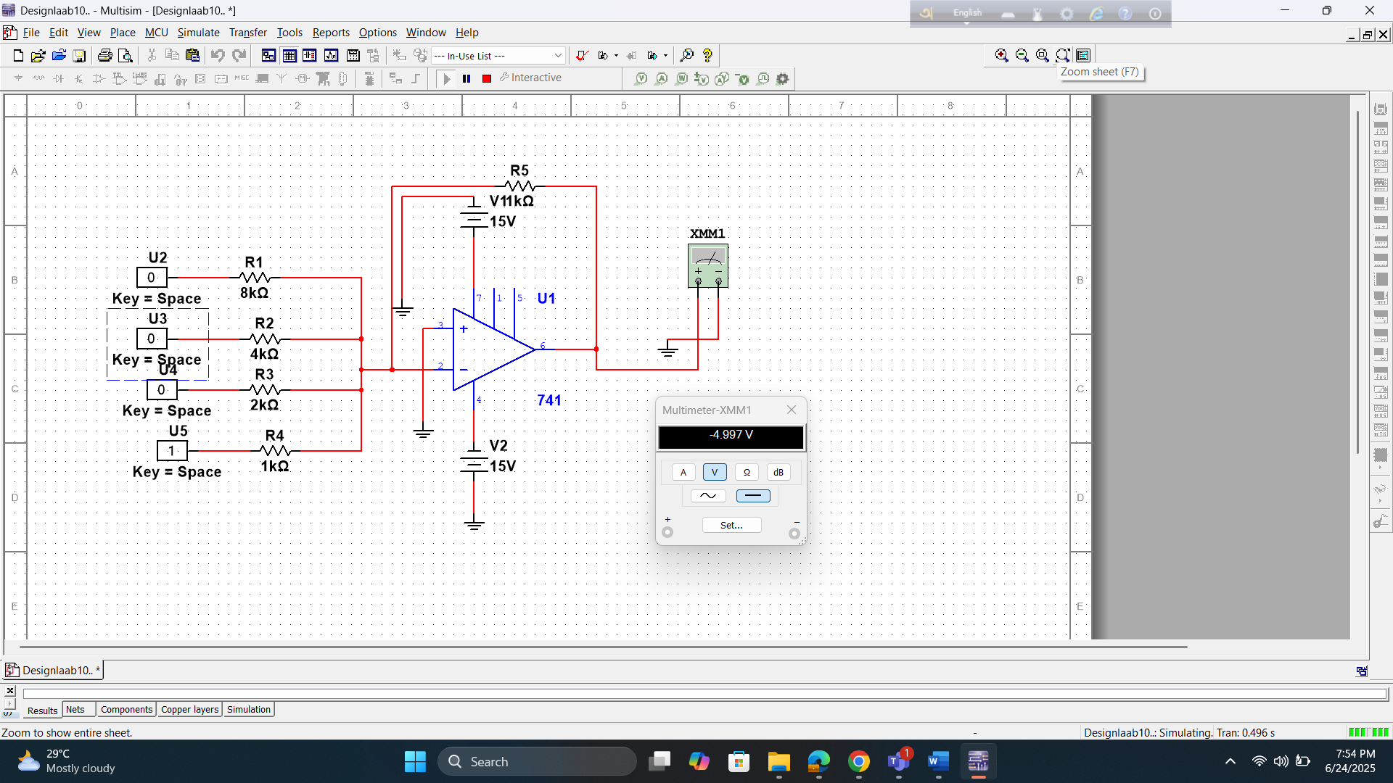

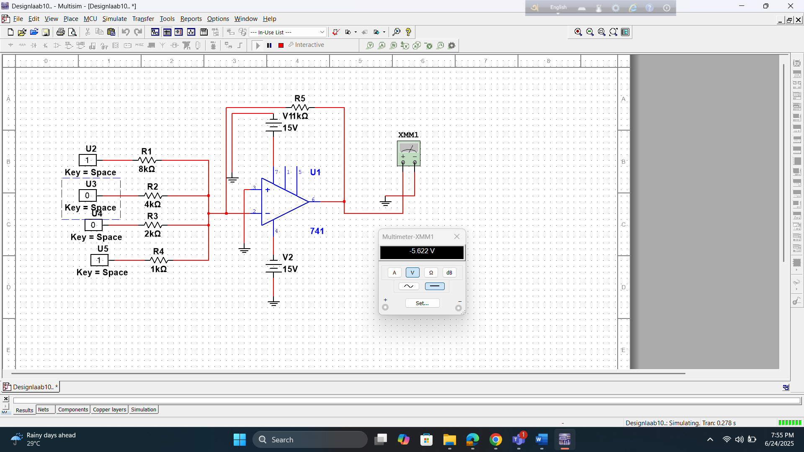

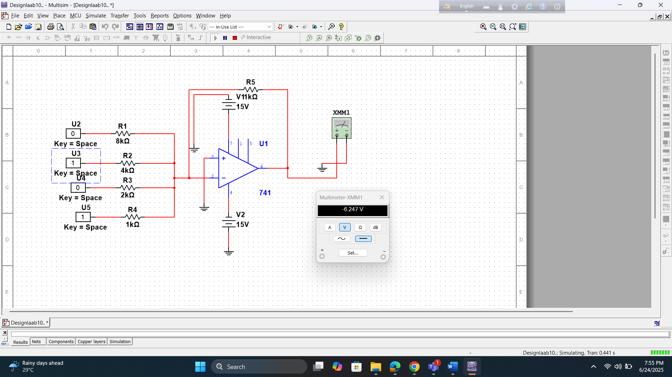

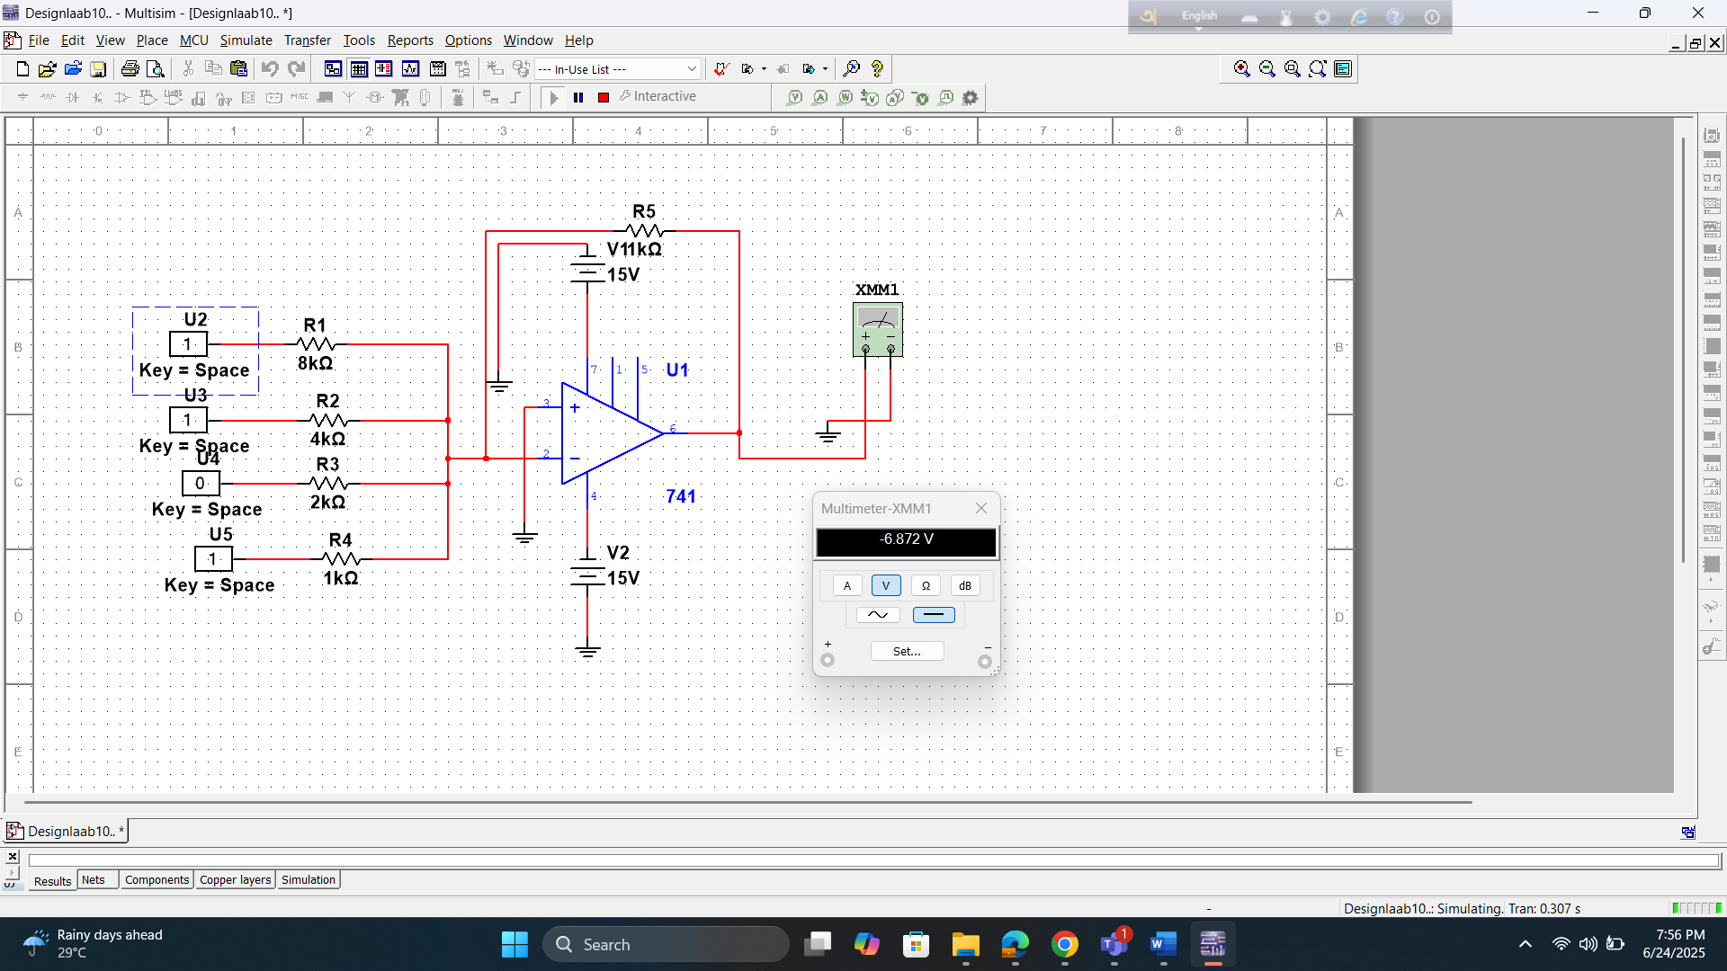

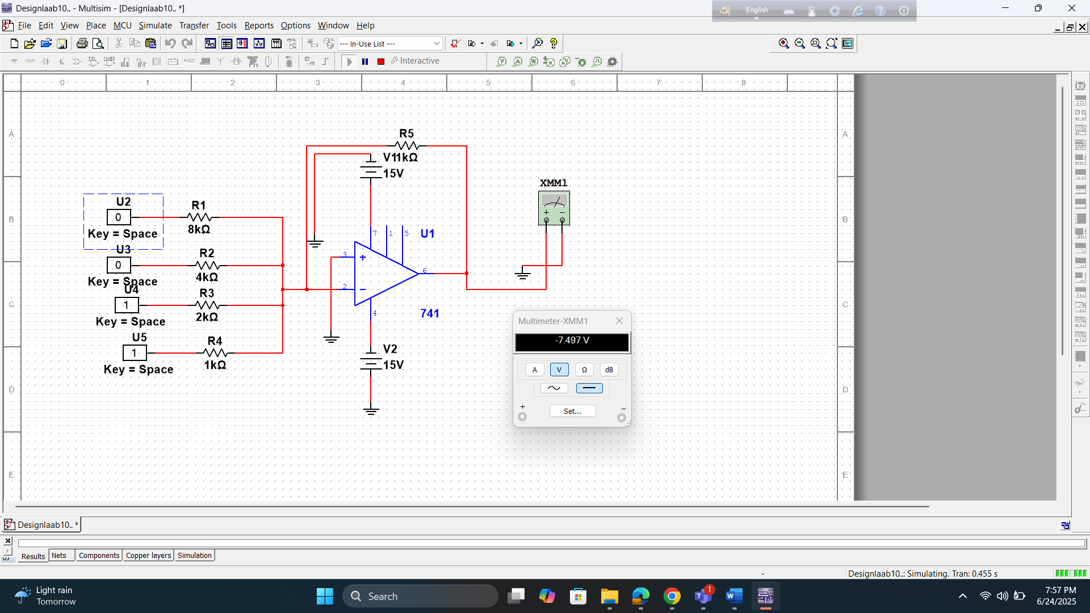

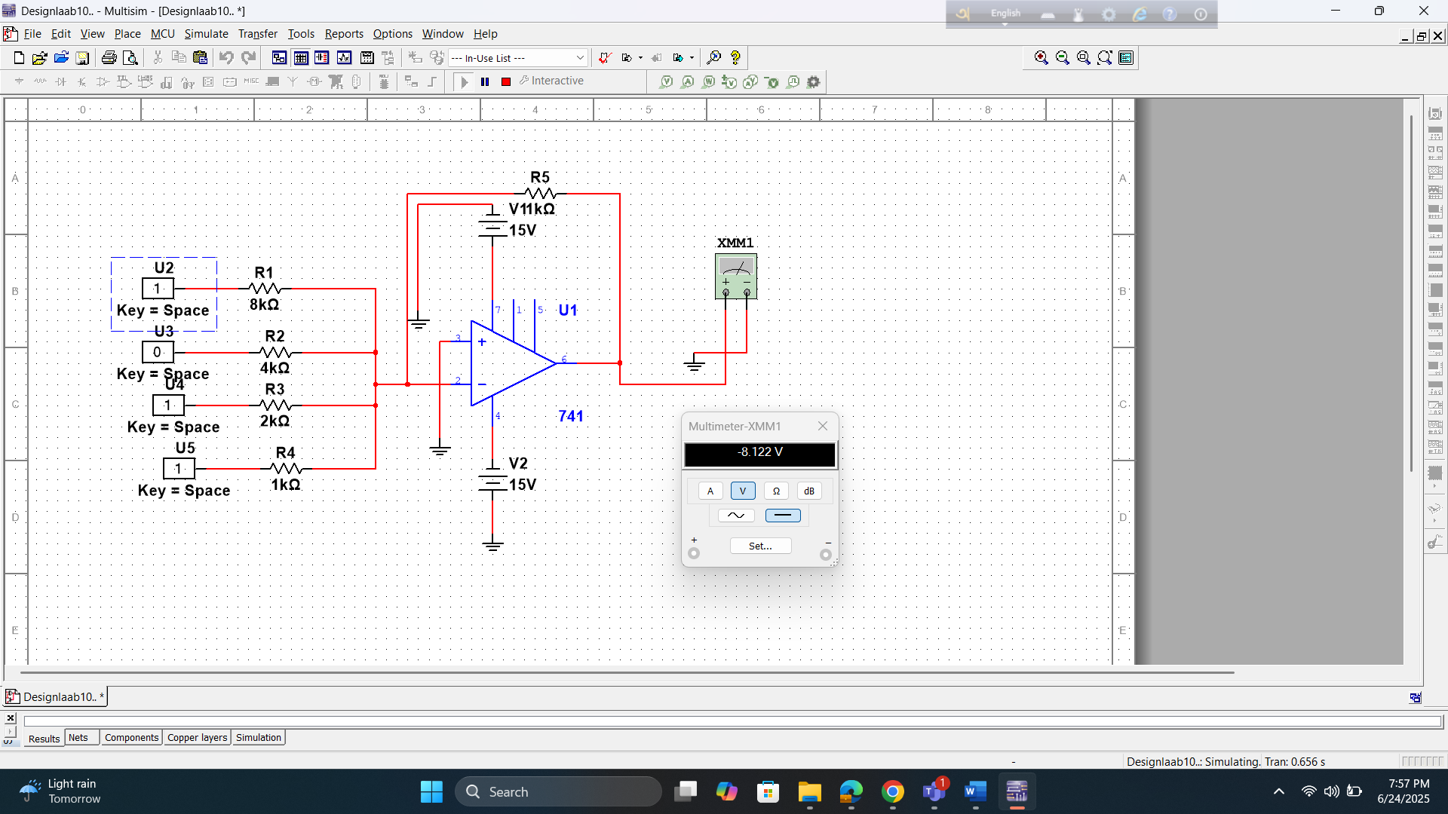

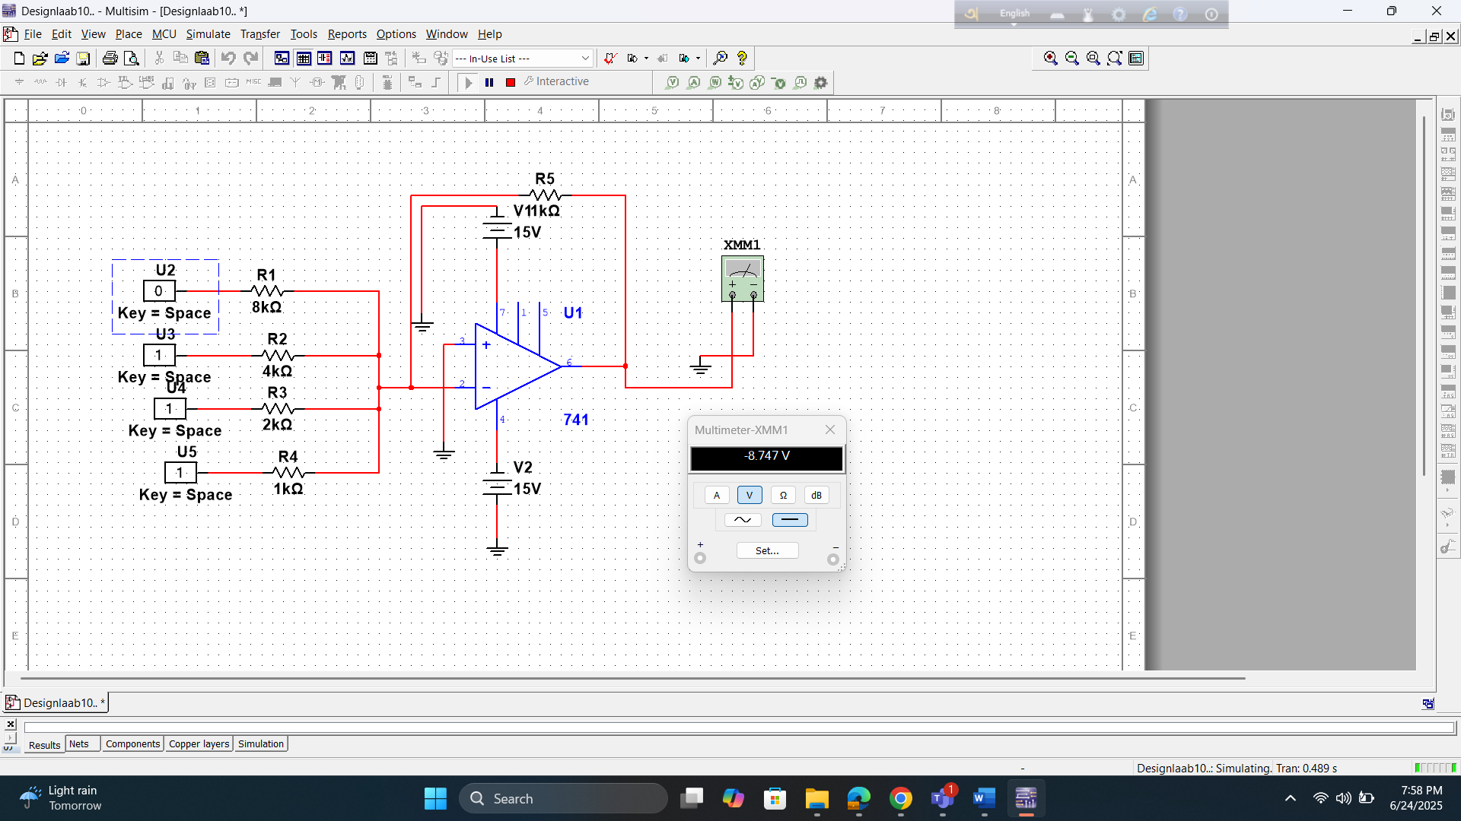

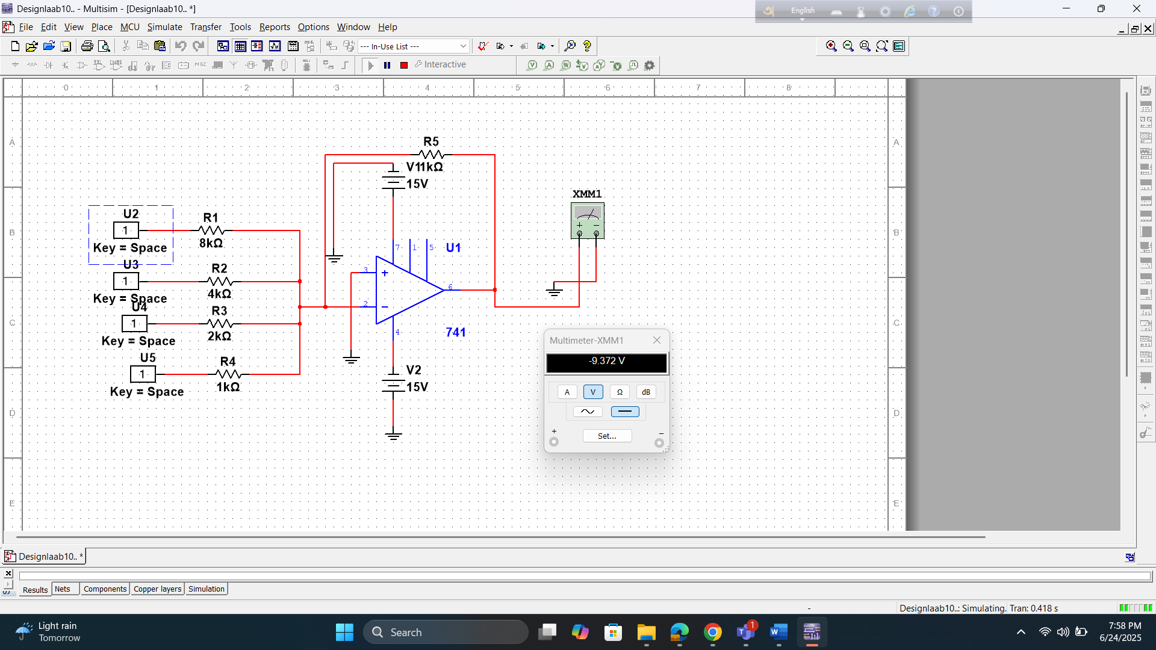

R/2R Ladder DAC

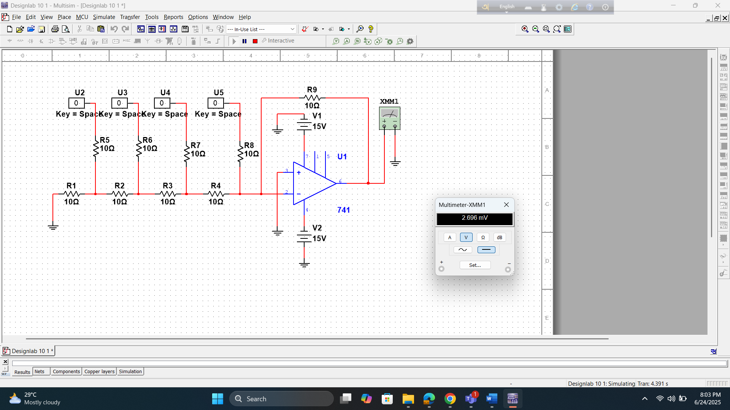

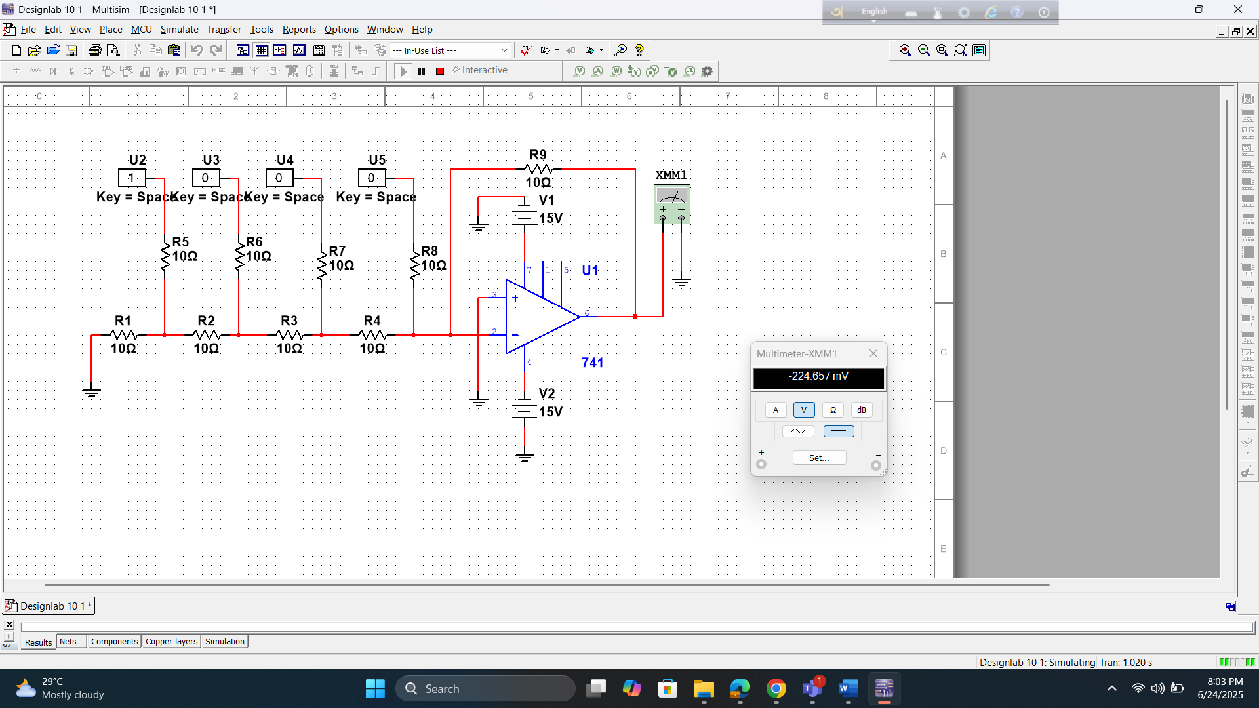

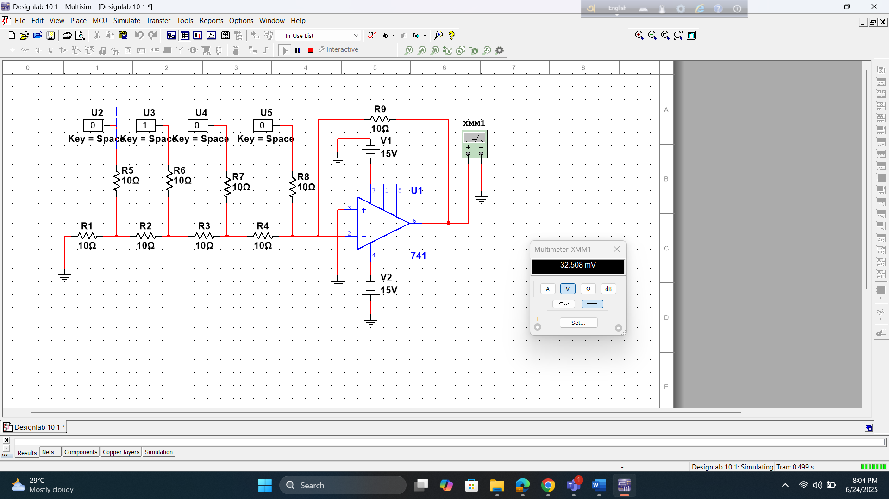

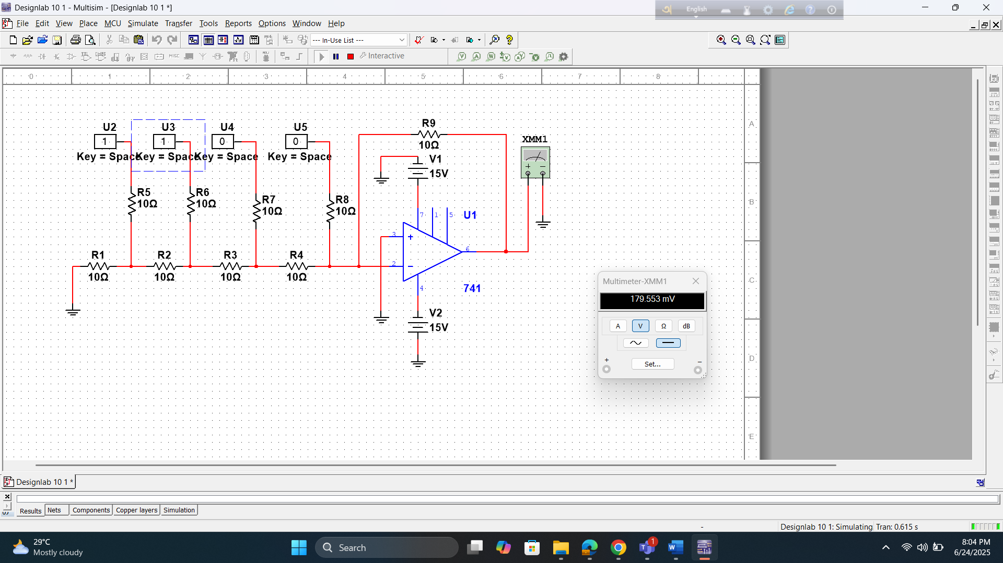

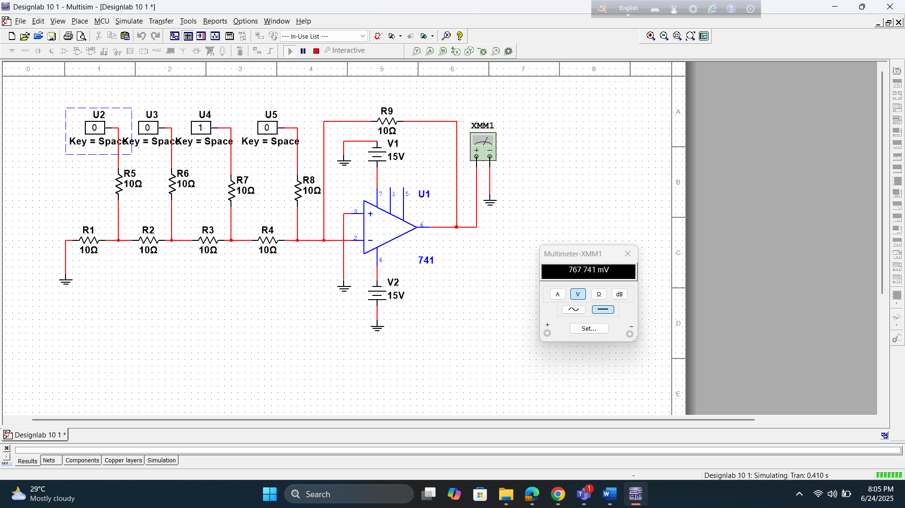

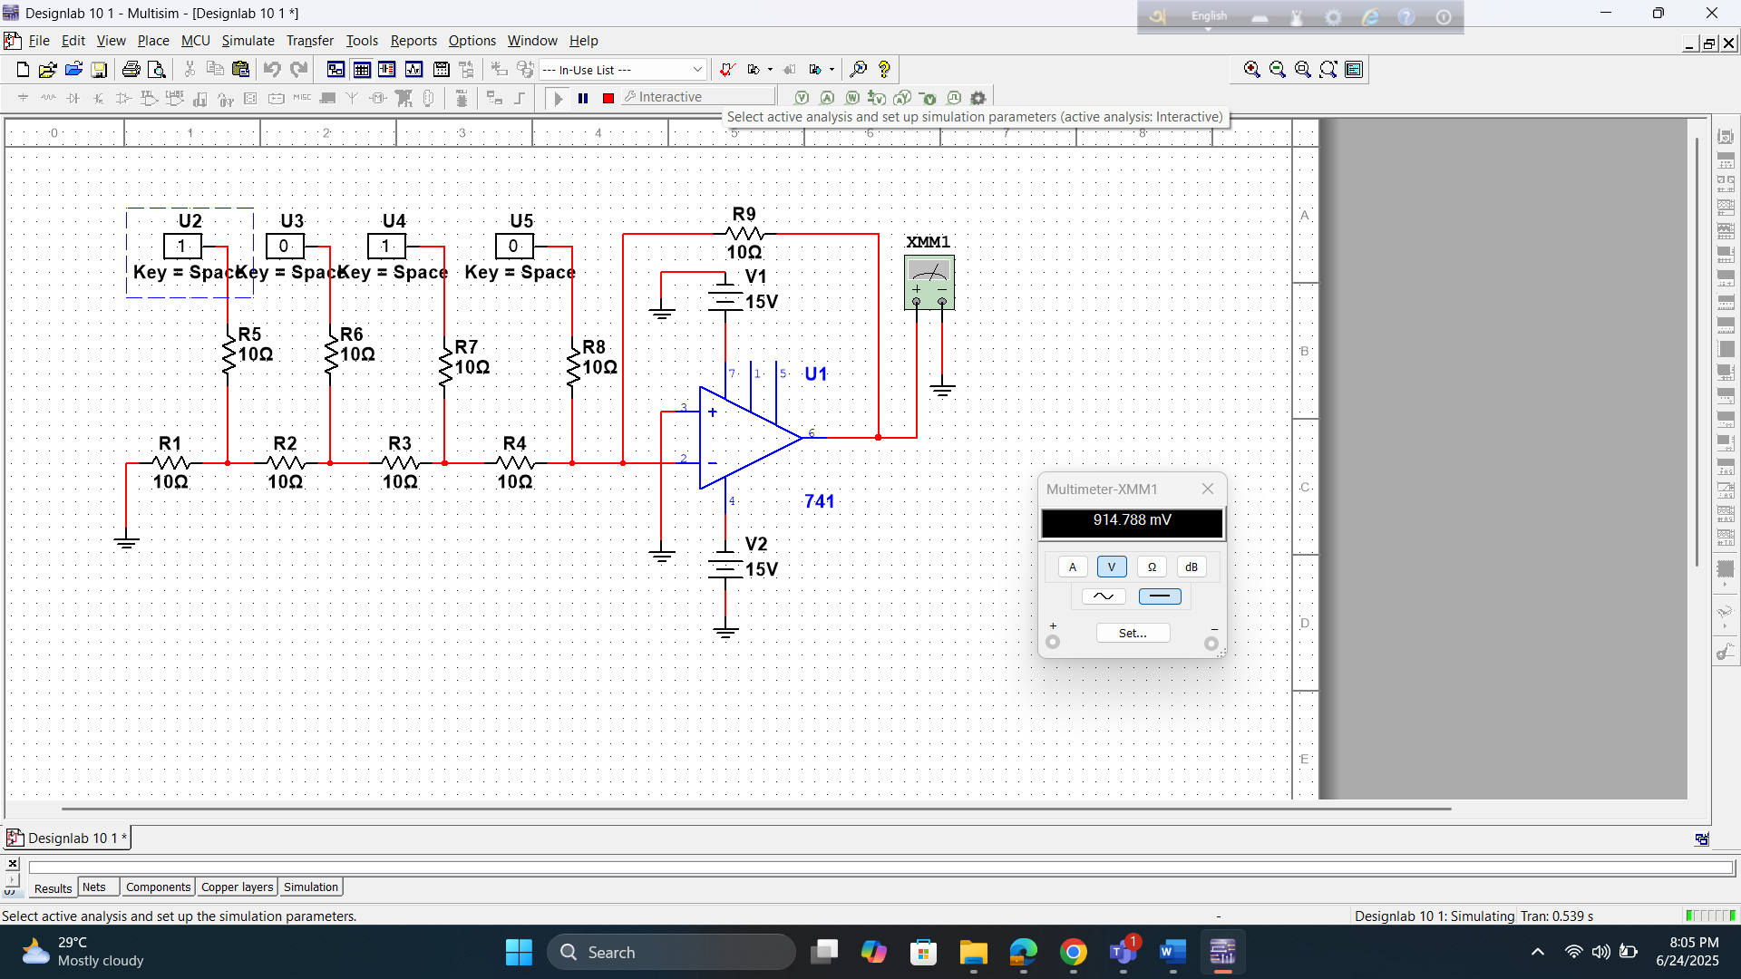

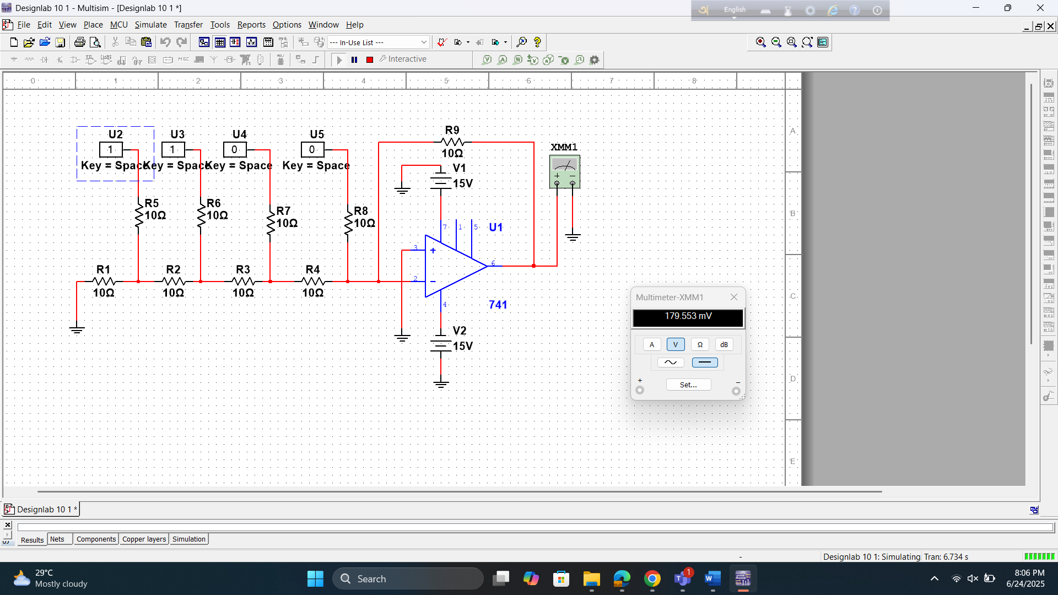

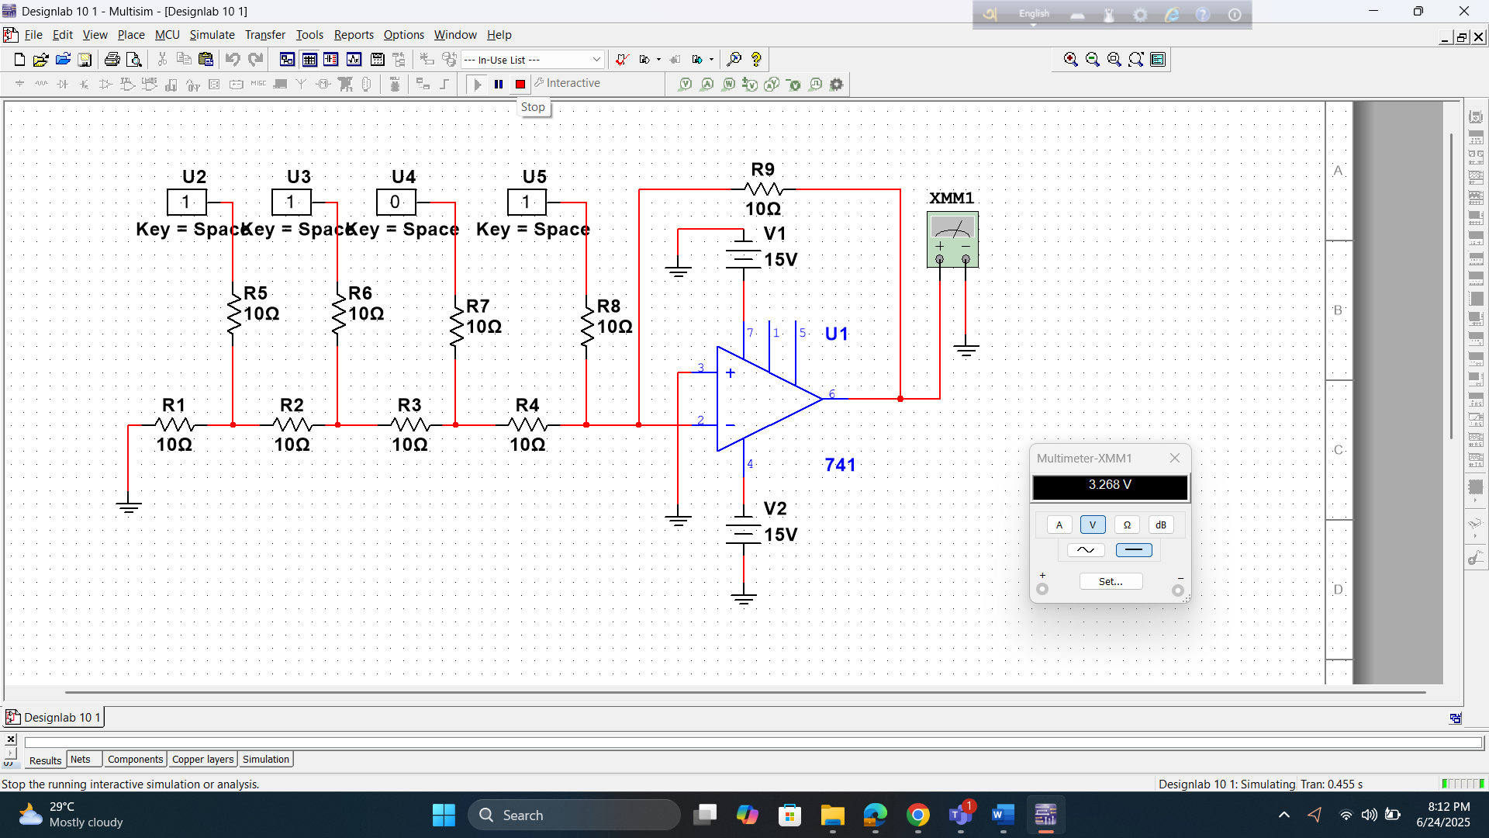

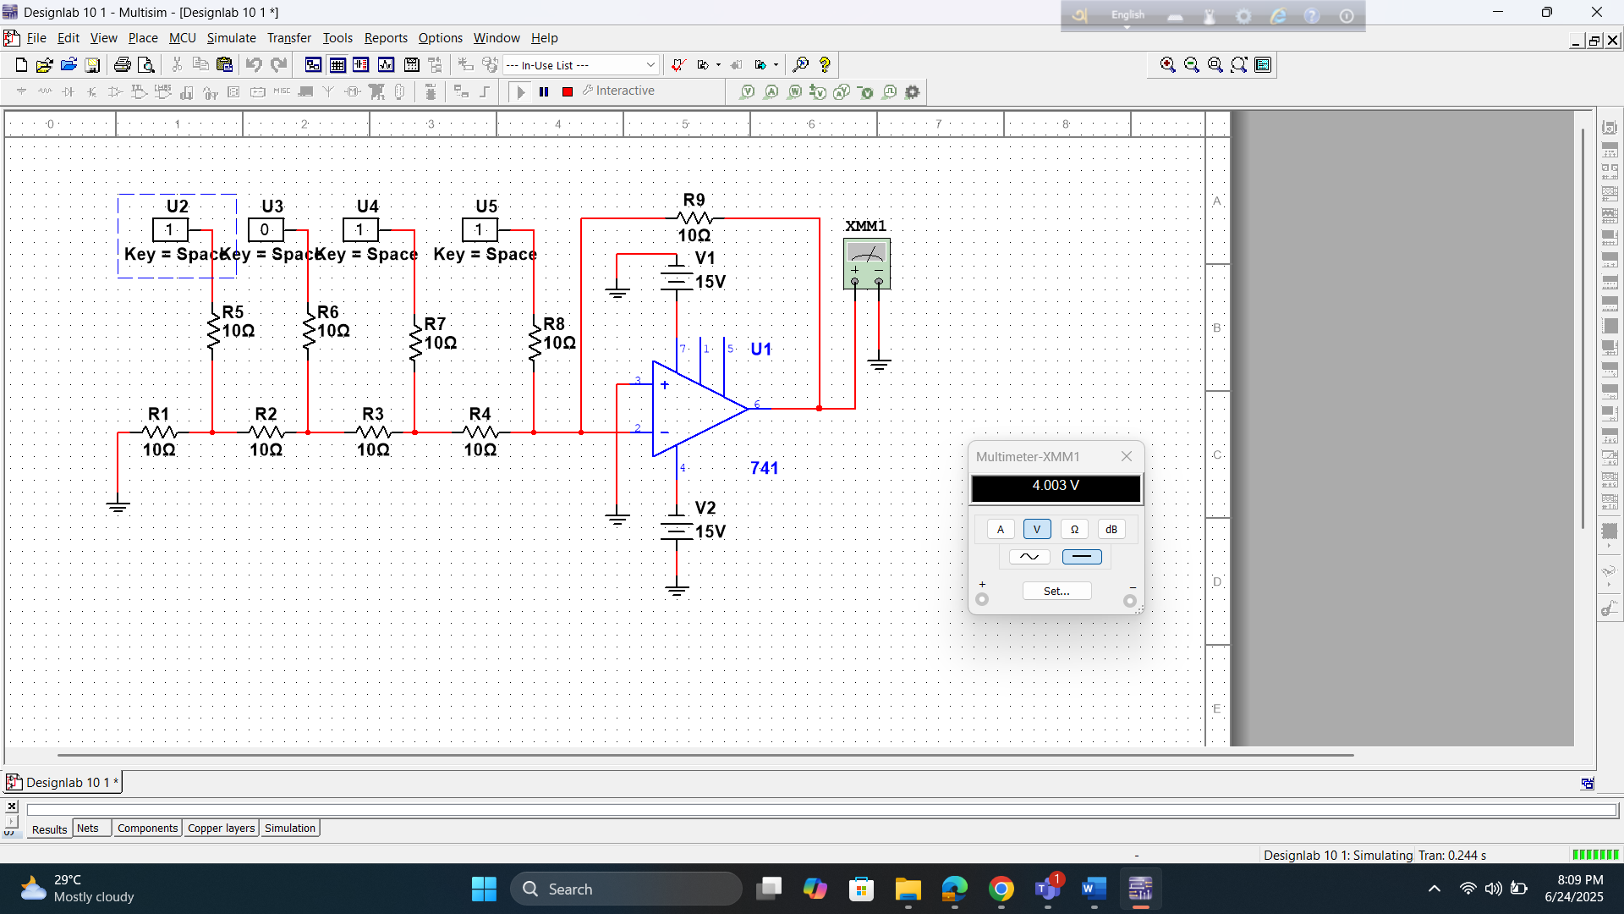

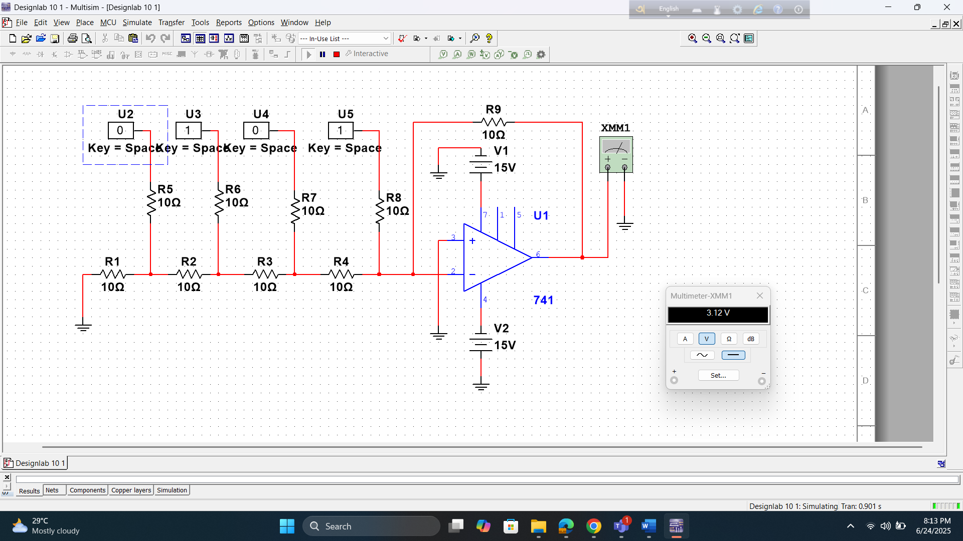

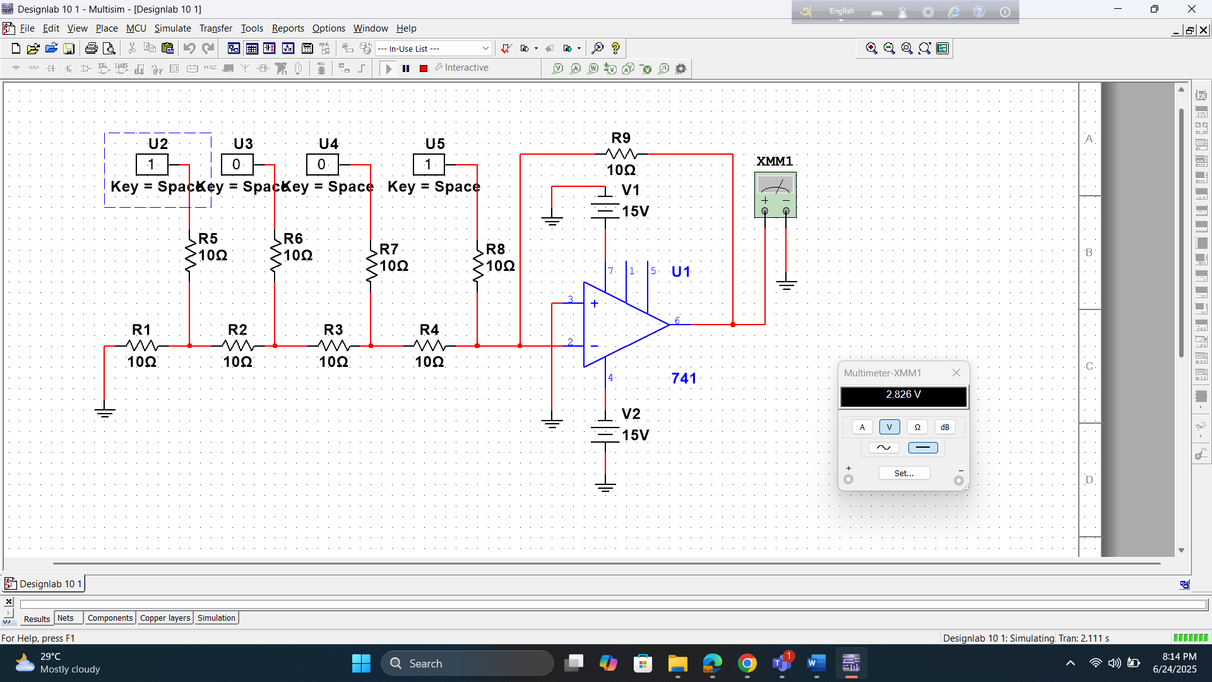

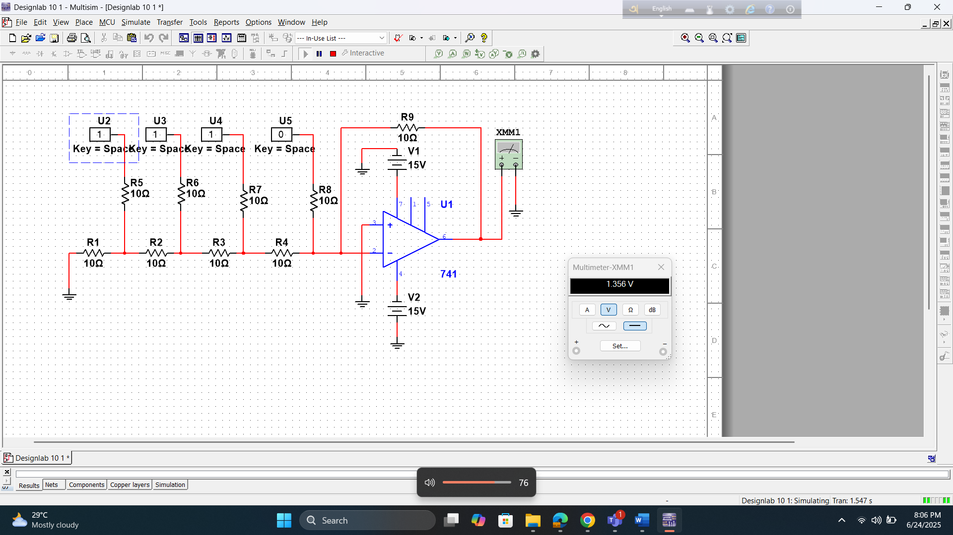

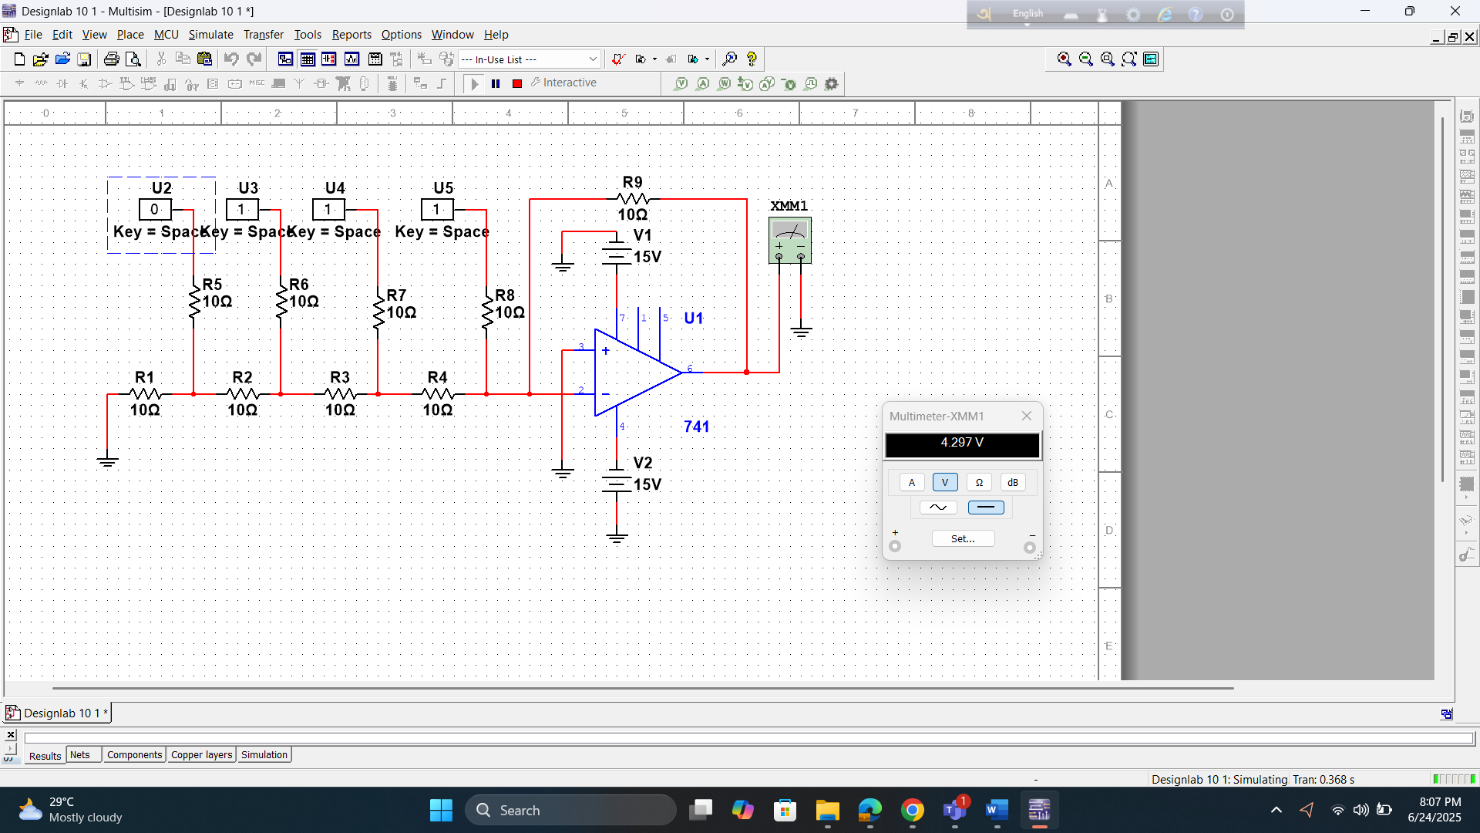

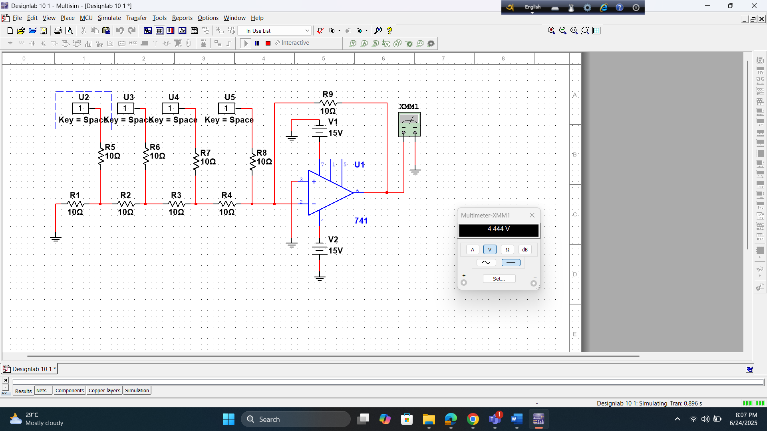

Result:
Table: Binary Weighted Digital to Analog converter:

D0 | D1 | D2 | D3 | M
0 | 0 | 0 | 0 | 3.029mV
0 | 0 | 0 | 1 | -621.962mV
0 | 0 | 1 | 0 | -1.247V
0 | 0 | 1 | 1 | -1.2872V
0 | 1 | 0 | 0 | -2.497V
0 | 1 | 0 | 1 | -3.122V
0 | 1 | 1 | 0 | -3.747V
0 | 1 | 1 | 1 | -4.372V
1 | 0 | 0 | 0 | -4.997V
1 | 0 | 0 | 1 | -5.622V
1 | 0 | 1 | 0 | -6.247V
1 | 0 | 1 | 1 | -6.872V
1 | 1 | 0 | 0 | -7.497V
1 | 1 | 0 | 1 | -8.122V
1 | 1 | 1 | 0 | -8.747v
1 | 1 | 1 | 1 | -9.372V

Table: R/2R Ladder DAC
D0 | D1 | D2 | D3 | M
0 | 0 | 0 | 0 | 2.696mV
0 | 0 | 0 | 1 | -224.657mV
0 | 0 | 1 | 0 | 32.508mV
0 | 0 | 1 | 1 | 179.553mV
0 | 1 | 0 | 0 | 767.741mV
0 | 1 | 0 | 1 | 914.788mV
0 | 1 | 1 | 0 | 179.553mV
0 | 1 | 1 | 1 | 1.356V
1 | 0 | 0 | 0 | 4.297V
1 | 0 | 0 | 1 | 2.826V
1 | 0 | 1 | 0 | 3.016V
1 | 0 | 1 | 1 | 3.024V
1 | 1 | 0 | 0 | 3.12V
1 | 1 | 0 | 1 | 3.268V
1 | 1 | 1 | 0 | 4.003V
1 | 1 | 1 | 1 | 4.444V

Questions for report writing:

- Why R/2R Ladder Digital-to-Analog Converter is preferable than Binary weighted Digital-to- Analog Converter?

Ans:
The R/2R Ladder Digital-to-Analog Converter (DAC) is generally preferred over the Binary Weighted DAC due to its simpler design, better accuracy, and improved scalability. One of the most significant advantages of the R/2R Ladder DAC is its use of only two resistor values: R and 2R. This simplicity makes it much easier to manufacture and ensures consistent performance because matching two resistor values is far more practical than producing a wide range of precise resistor values. In contrast, the Binary Weighted DAC requires resistors scaled by powers of two (such as 𝑅,2𝑅,4𝑅,8𝑅), making it difficult to achieve precise resistor values, especially as the resolution increases.

Accuracy and linearity are also major benefits of the R/2R Ladder DAC. Since it uses only two resistor values, the chances of mismatch are greatly reduced, leading to more consistent and linear analog output. On the other hand, the Binary Weighted DAC is prone to non-linearity because even slight inaccuracies in the resistor values, particularly in the higher-order bits, can cause significant errors in the output signal. This makes the R/2R Ladder DAC more reliable in producing accurate analog signals.

Scalability is another area where the R/2R Ladder DAC outperforms the Binary Weighted DAC. Expanding the resolution of an R/2R Ladder DAC simply involves adding more stages with the same two resistor values, making it easy to design higher-bit DACs. However, increasing the resolution of a Binary Weighted DAC requires precise fabrication of very large and very small resistor values, which becomes increasingly impractical as the number of bits increases. This limitation makes the Binary Weighted DAC unsuitable for high-resolution applications.

Additionally, the R/2R Ladder DAC is more power-efficient. Its uniform structure allows for balanced current distribution, which reduces overall power consumption. In contrast, the Binary Weighted DAC can consume more power, especially as the resolution increases, due to the

varying currents across its resistors. This makes the R/2R Ladder DAC a more suitable choice for power-sensitive applications.

The design and layout of the R/2R Ladder DAC are also much simpler. The repeated pattern
R and 2𝑅 resistors creates a straightforward and compact circuit, making it easier to implement on printed circuit boards (PCBs). In comparison, the Binary Weighted DAC’s varying resistor values complicate circuit design and can lead to more errors in the layout process. This simplicity in design not only improves reliability but also reduces manufacturing costs. Since the R/2R Ladder DAC requires only two standard resistor values, production is more cost-effective than the Binary Weighted DAC, which demands precise and varied resistor values, increasing both complexity and cost.
In summary, the R/2R Ladder DAC is favored over the Binary Weighted DAC because of its simpler and more consistent design, higher accuracy, easier scalability, lower power consumption, and reduced production costs. These advantages make it a more practical and reliable choice for most digital-to-analog conversion applications.

- Draw the wave shapes for binary output lines against analog input and sampling pulses?
Ans:
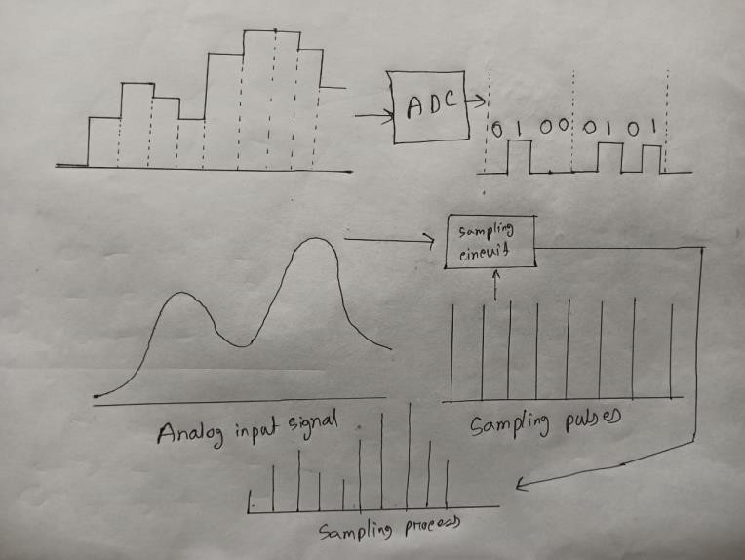

Discussion and Conclusion:
The experiment was largely successful in achieving its primary goal — to demonstrate and compare the functionality of the Binary Weighted DAC and the R/2R Ladder DAC. The digital input values produced corresponding analog outputs, confirming proper DAC operation in both configurations.
However, some minor errors may have occurred during setup, such as loose connections or incorrect resistor placements, which could have affected initial readings. These issues were identified and corrected during the process.

Part II: Design of a flash Analog to Digital Converter

Theory and Methodology:

Flash converters are extremely fast compared to many other types of ADCs which usually narrow in on the "correct" answer over a series of stages. Compared to these, a Flash converter is also quite simple and, apart from the analog comparators, only requires logic for the final conversion to binary.

For best accuracy often a sample-and-hold circuit is inserted in front of the ADC input. This is needed for many ADC types (like successive approximation ADC), but for Flash ADCs there is no real need for this, because the comparators are the sampling devices.

A Flash converter requires a huge number of comparators compared to other ADCs, especially as the precision increases. A Flash converter requires comparators for an n-bit conversion. The size, power consumption and cost of all those comparators make Flash converters generally impractical for precisions much greater than 8 bits (255 comparators). In place of these comparators, most other ADCs substitute more complex logic and/or analog circuitry which can be scaled more easily for increased precision.

Implementation:
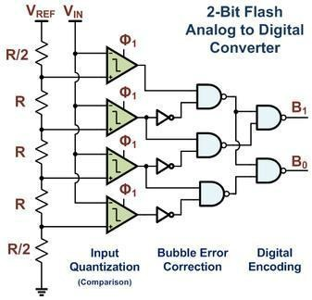
© Dept. of EEE, Faculty of Engineering, American International University-Bangladesh (AIUB) 5

Fig1: A 2-bit Flash ADC Example Implementation with Bubble Error Correction and Digital Encoding

Flash ADCs have been implemented in many technologies, varying from silicon based bipolar (BJT) and complementary metal oxide FETs (CMOS) technologies to rarely used III- V technologies. Often this type of ADC is used as a first medium sized analog circuit verification.

The earliest implementations consisted of a reference ladder of well matched resistors connected to a reference voltage. Each tap at the resistor ladder is used for one comparator, possibly preceded by an amplification stage, and thus generates a logical '0' or '1' depending if the measured voltage is above or below the reference voltage of the resistor tap. The reason to add an amplifier is twofold: it amplifies the voltage difference and therefore suppresses the comparator offset, and the kick-back noise of the comparator towards the reference ladder is also strongly suppressed. Typically designs from 4-bit up to 6-bit, and sometimes 7-bit are produced.

Designs with power-saving capacitive reference ladders have been demonstrated. In addition to clocking the comparator(s), these systems also sample the reference value on the input stage. As the sampling is done at a very high rate, the leakage of the capacitors is negligible.

Recently, offset calibration has been introduced into flash ADC designs. Instead of high precision analog circuits (which increase component size to suppress variation) comparators with relatively large offset errors are measured and adjusted. A test signal is applied and the offset of each comparator is calibrated to below the LSB size of the ADC.

Another improvement to many flash ADCs is the inclusion of digital error correction. When the ADC is used in harsh environments or constructed from very small integrated circuit processes, there is a heightened risk a single comparator will randomly change state resulting in a wrong code. Bubble error correction is a digital correction mechanism that will prevent a comparator that has, for example, tripped high from reporting logic high if it is surrounded by comparators that are reporting logic low.

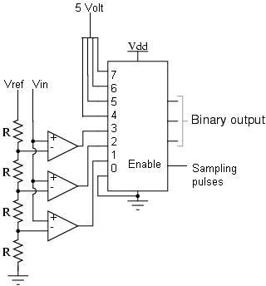
This circuit is the simplest to understand. It is constructed from a series of comparators, each one comparing the input signal to a unique reference voltage. The comparator outputs connect to the inputs of a priority encoder circuit, which then produces a binary output. The following illustration shows a Flash ADC 2-bit circuit:
Fig 2: A 2 bit flash ADC.
© Dept. of EEE, Faculty of Engineering, American International University-Bangladesh (AIUB) 6

An N bit flash ADC requires 2N – 1 number of comparators.

Vref is a stable reference voltage provided by a precision voltage regulator as part of the converter circuit, not shown in the schematic. As the analog input voltage exceeds the reference voltage at each comparator, the comparator outputs will sequentially saturate to a high state. The priority encoder generates a binary number based on the highest-order active input, ignoring all other active inputs.

If the previous circuit does not work out, please use the circuit below:

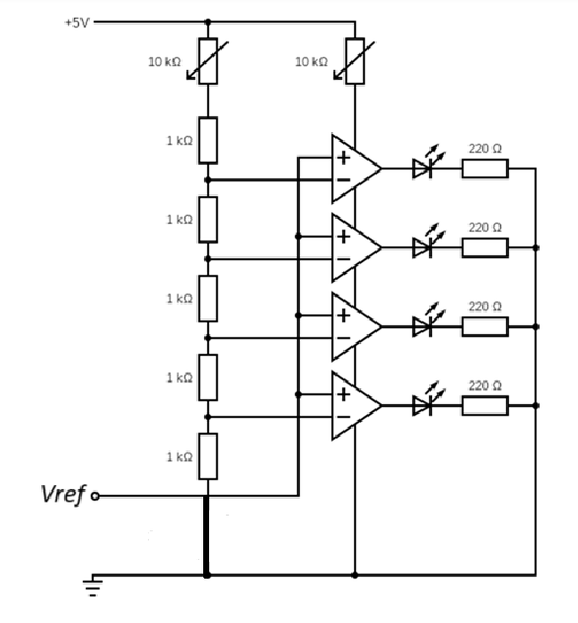

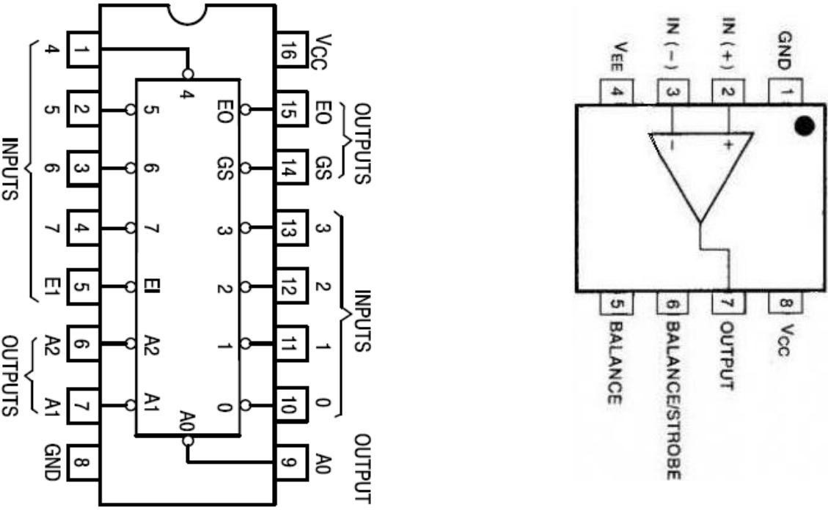
IC Pin Configurations:

Introduction:
Flash analog-to-digital converters, also known as parallel ADCs, are the fastest way to convert an analog signal to a digital signal. Flash ADCs are ideal for applications requiring very large bandwidth, but they consume more power than other ADC architectures and are generally limited to 8-bit resolution. This tutorial will discuss flash converters and compare them with other converter types.
In this experiment, students will learn how flash ADC works by implementing a 2 bit flash ADC.

Apparatus:

1) | Trainer Board | :
2) | Op-Amp | : | IC741
3) | Resistors | : | 1KΩ
4) | 8 to 3 bit priority encoder | : | IC74148

Precautions:
All wiring should be carefully inspected to ensure correctness and safety. The power supply should not be activated until the circuit has been verified by the instructor. Proper voltage levels must be maintained to prevent any potential damage to the chip. Any uncertainty in connections should be clarified before proceeding.

Experimental Procedure:

A 2-bit flash ADC should be constructed using a resistor ladder network and comparators. Different input voltage levels should be applied, and the corresponding digital output values must be recorded. For each input level, the output waveforms should be observed and sketched using an oscilloscope. The transitions in output must be noted carefully as the input voltage is varied. All observations should be documented, and the behavior of the ADC should be analyzed based on the collected data.
Experiment:

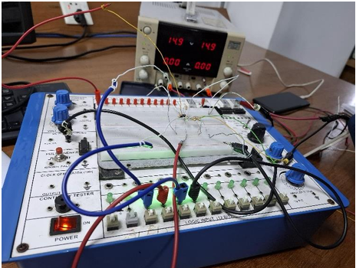

Fig : 2 bit flash ADC.

Simulation and Measurement:
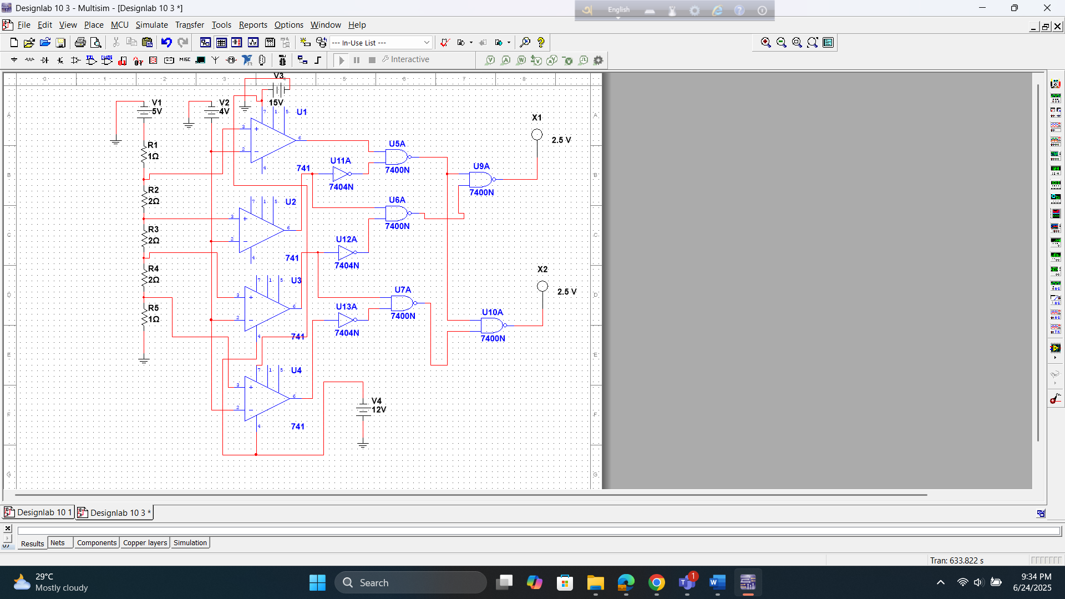
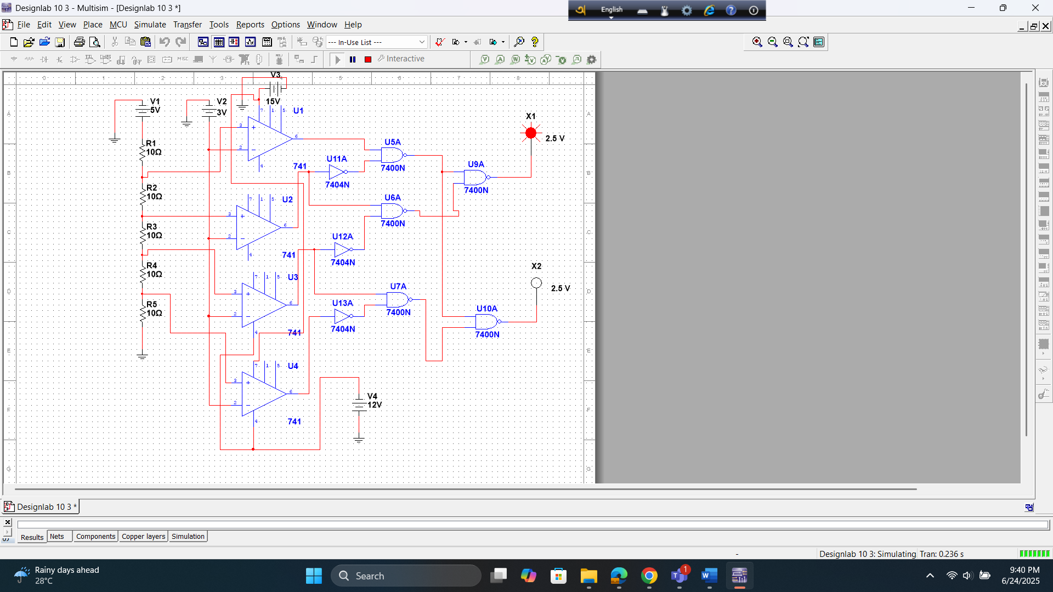
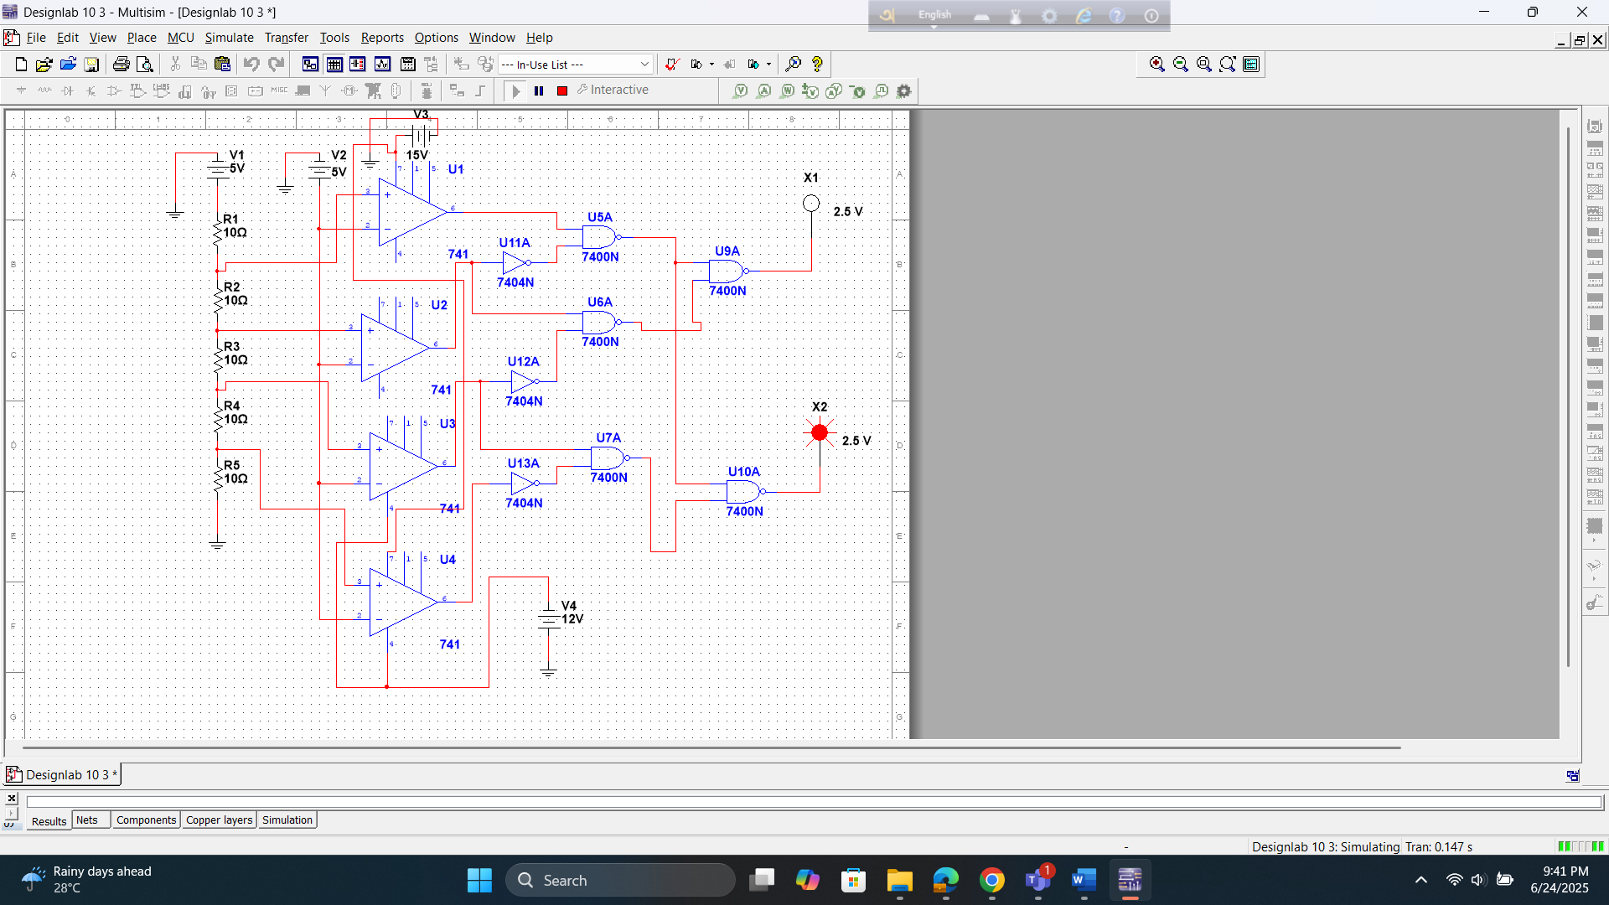

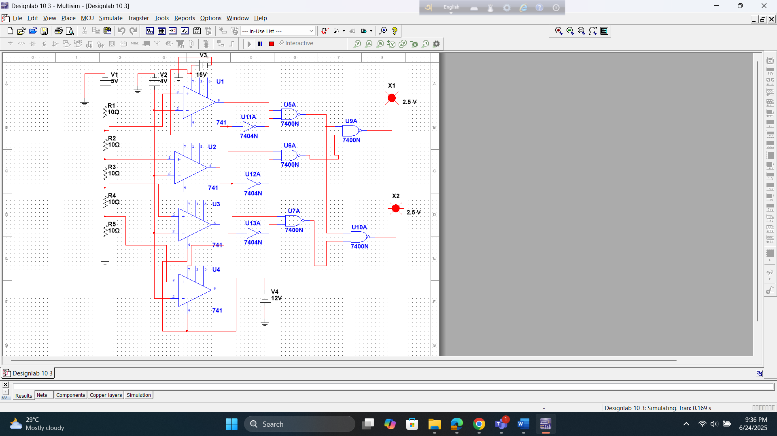

Discussion:
The data obtained should be analyzed to determine how effectively the experiment met its initial objective—demonstrating the working principle of a 2-bit flash ADC. The output values recorded for different input voltages should be compared with expected digital outputs to assess accuracy.
If any discrepancies were observed, they may have been caused by issues such as incorrect comparator reference levels, loose connections, or improper input voltage range. These mistakes should be identified and noted.
wave shapes for binary output lines against analog input and sampling pulses.

Reference:
thThomas L. Floyd, Digital Fundamentals, 9 Edition, 2006, Prentice Hall.
1.

